Government Performance Management System User Manual

Contents
1. Login Page 3
2. Dashboard 3
2.1. Agency User 3
2.2. GPMD Dashboard 4
3. Admin User 4
3.1. Master Data Management 4
4. APA Preparation 9
4.1. Section 1 11
4.2. Section 2 12
4.3. Update SI Budget 13
4.4. Section 3 15
4.5. Section 5 16
4.6. APA Preview 17
5. APA Review by IRC 18
6. NTC Review APA 22
7. APA Monitoring 26
8. Record Issues – Departments and Divisions 27
9. Agency Level Issues 29
10. Mid-Year Review 31
10.1. Mid Year Review Submission 31
11. Year End Evaluation 32
11.1. Self Assessment 32
11.2. IRC Assessment 33
11.3. NTC Assessment 35
11.4. GPMD Assessment 36
12. Report 38

User is required to access system using the URL provided by the system administrator. Login page is provided as follows.

Login Page
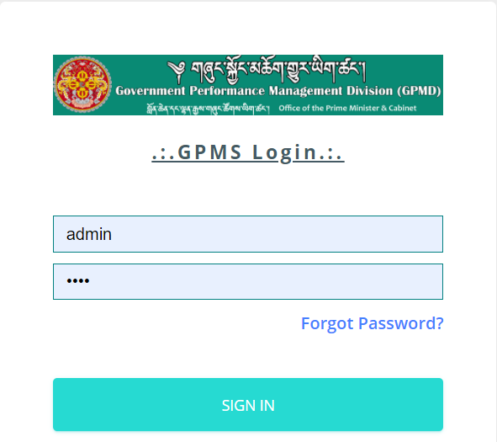
User will enter the system access credentials (username and password) and then click Sign In Button. If the provided credentials match the credentials in the system, user will be provided with the user Dashboard. Dashboard will provide information as per the roles and permission attached with the role.

Dashboard

Agency User
Upon successful login, agency user is provided with set of menus on the left and a dashboard that provides important information.
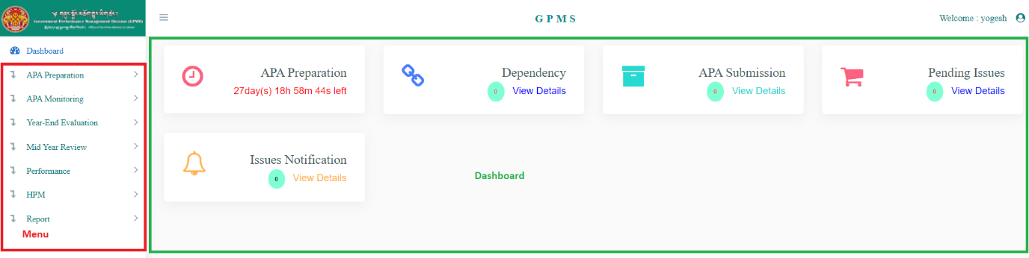
Menu is based on the access control configured by the system administrator and may change based on the role of the user in preparation, monitoring and evaluation of Annual Performance Agreement.
The Dashboard provides the following information:
- APA Preparation – This provides information on whether APA preparation is on or locked. If APA preparation is on then it provides the time left to complete APA preparation. The APA preparation time is configured by the system administrator.
- Dependency – This provides information on the dependent agencies with which the agency is required to collaborate to achieve APA targets.
- APA Submissions – APA submissions made by the departments and division under the agency.
- Pending Issues – Any Issues reported with in the agency
- Issue Notifications – Notifications on the issues reported by Departments and Divisions under the agency.

GPMD Dashboard
Upon successful login, agency user is provided with set of menus on the left and a dashboard that provides important information.
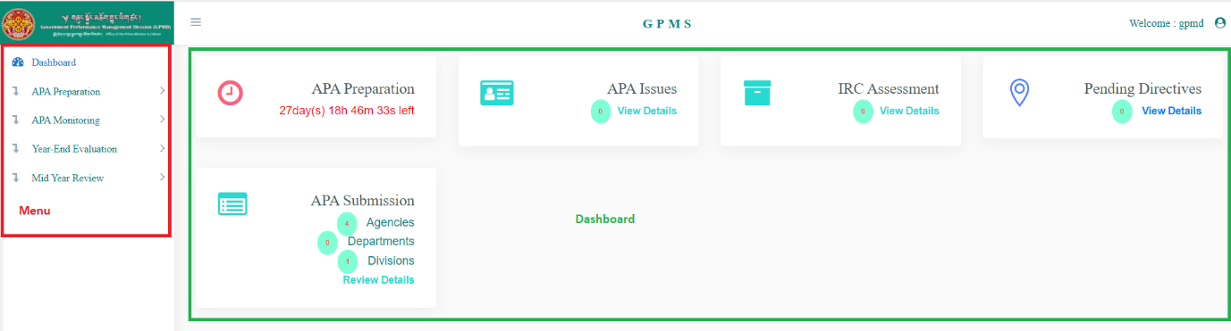
Menu is based on the access control configured by the system administrator and may change based on the role of the user in preparation, monitoring and evaluation of Annual Performance Agreement.
The Dashboard provides the following information:
- APA Preparation – This provides information on whether APA preparation is on or locked. If APA preparation is on then it provides the time left to complete APA preparation. The APA preparation time is configured by the system administrator.
- APA Issues – Issues reported by agencies that are not resolved.
- IRC Assessment – Annual progress submitted by agencies and internal review committee assessments are complete.
- Pending Directives – List of directives that issued from HPM’s office but not forwarded to the agencies by GPMD.
- APA Submissions – notifications on APA submitted by agencies, departments and divisions.

Admin User

Master Data Management
Admin user have the provision to manage master Data. Master data is the data set that is repeatedly used across the system like Role, User, Financial Year, APA Schedule, etc.
Role
Role menu is used to either create new role or change the permission of existing role. Any changes in the access for existing role can be managed using the permission edit option.
Permission
Change permission or assign new permission to newly created role is done as follows:
- Access the System
- Login into the using the credentials provided by admin user
- Navigate to Master -- > Role Menu. Following page is provided.
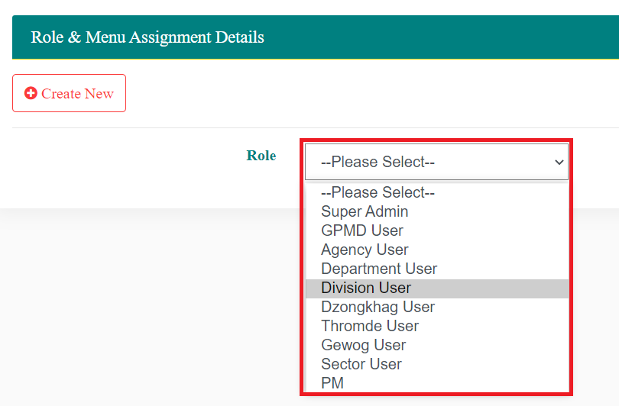
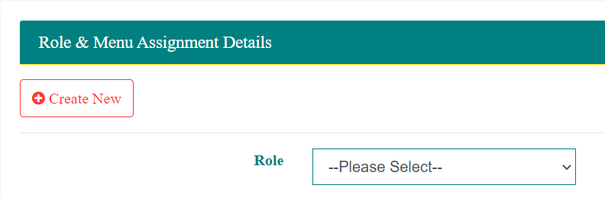
All the roles that are already created as available in the list.

- Select the relevant Role for which permission needs to be added or modified. List of pages / functions in the system is provided with option to select.
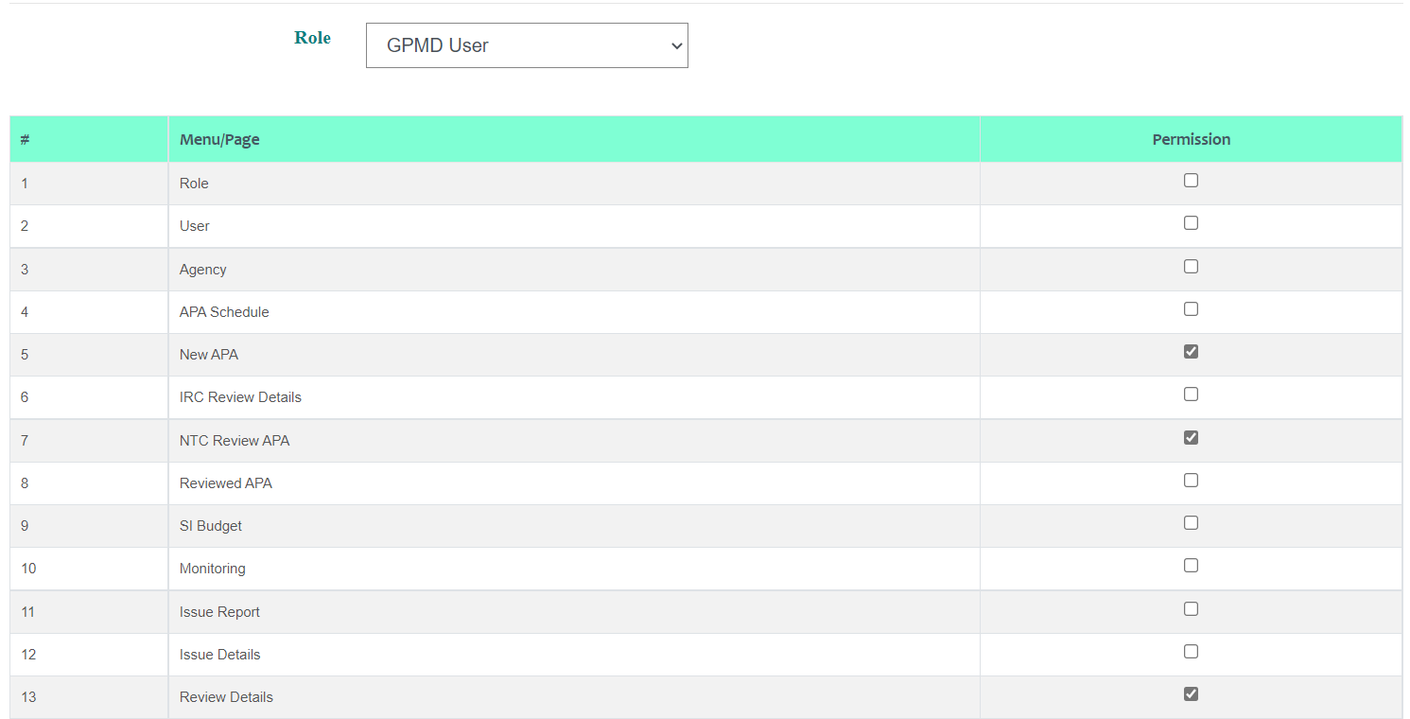
- To add the access permission click . Upon selection of menu for selected user it appears .
- To remove permission to access any page click . Tick mark will be removed. Continue to add and / or remove the access as required and then Update to save the changes.
New Role
New role can be created as follows:
Change permission or assign new permission to newly created role is done as follows:
- Access the System
- Login into the using the credentials provided by admin user
- Navigate to Master -- > Role Menu. Following page is provided.

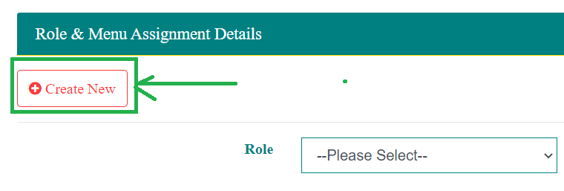
- Click on the Create New Button.

- New Role add option is provided as follows:
- Enter the name of the role and then Create to save the new role or click to view the list of roles already created roles in the dropdown.
- After creating the role, follow permission section to assign permission to the newly created role.
User
User menu is used to either create new user or modify existing user. Any changes in the access for existing user can be managed by changing the role. Other information can be changed also.
Change permission or assign new permission to newly created role is done as follows:
- Access the System
- Login into the using the credentials provided by admin user
- Navigate to Master -- > User Menu. A page with the following features is provided:
  - Create New – Option to create new user.
  - List of Existing – List of users already created in the system is provided
  - Show XX entries – Option to specify how many records to be displayed in the table. This configuration only impacts the machine of the user. Other users are not impacted.
  - Search – Option to search the record displayed on the page. Search is done on the page only. It is not done from the backend database.
  - Showing …. -- Details of home many records are displayed of the total records
  - Previous <> Next – Option to navigate to different pages.
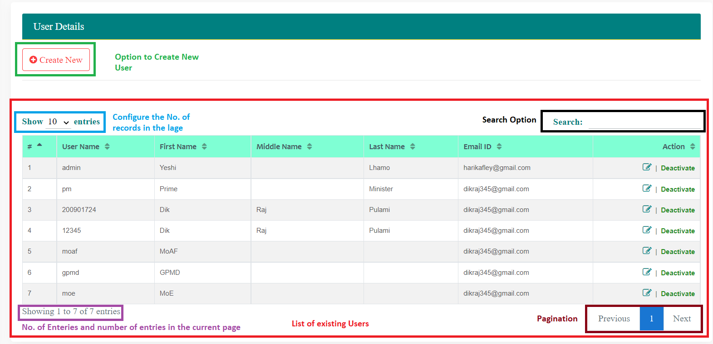
Following Actions can be taken on the existing users:
- Edit – Provision to change the user information. If a user is transferred from one agency to another then Edit feature can be used to change the agency.
- Deactivate – Make the user inactive. Inactive user cannot login into the system.
- Activate – Any user deactivate can be activated any time.
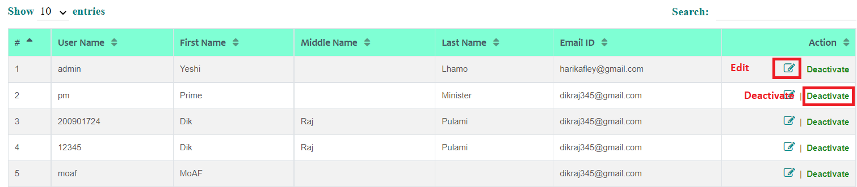
To edit information of existing user, logged in user is required to click (Edit) option. Existing user information is displayed.
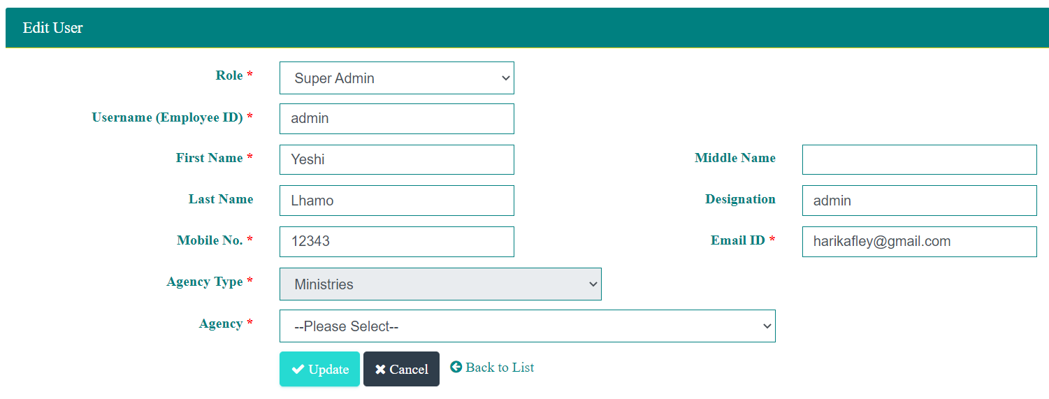
Modify the information and click Update to save the modified information or Cancel to abort saving the changed information. User can always use to view the list of existing users.
New User
In order to create new user, admin user is required to navigate to User and then click on Create New Button. Option to create new user is provided as follows.
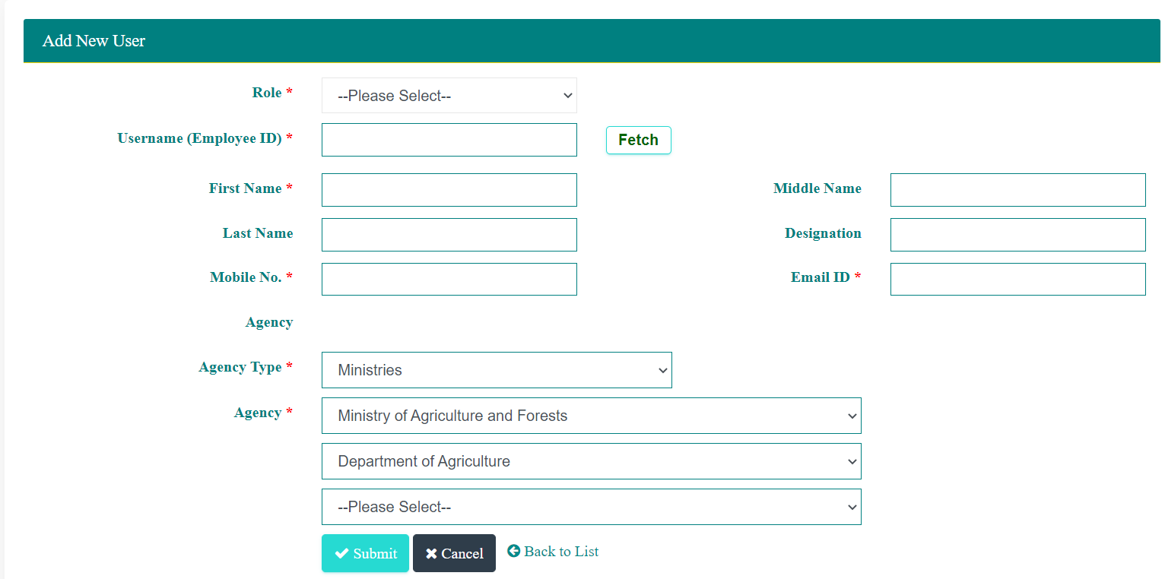
Information to be processed include:
- Role – Role to be assigned to the user
- User (Employee ID) – RCSC Employee ID which is to be used as user name also. Information of the user can be pulled from ZEST system using Employee ID. If the user is not from ZEST details can be entered.
- User Information – Name, Designation, Mobile No., Email. Name (First Name, Middle Name and Last Name) can be fetched from ZEST. Alternatively, user can record the details as well if connection is not available.
- Agency – User can be created up to Division Level. Once Agency is selected option to select Departments and Divisions under the department is provided.
After entering required details admin user is required to click Submit to save the new user information. To abort user creation user can Cancel. User can use to navigate to the list of existing users.
Add Agency
Admin user can add agency as follows:
- Access the System
- Login into the using the credentials provided by admin user
- Navigate to Master -- > Agency Menu. Following page is provided.
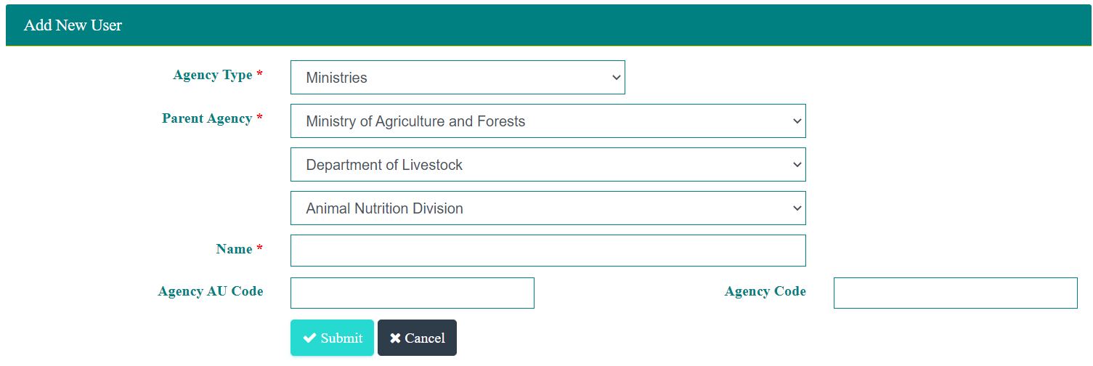
Following logic is applied while creating agency:
- Agency Type is mandatory and user is required to select. Agency type includes Ministries, Autonomous Agencies, Local Government, Constitutional, His Majesty Secretariat, Judiciary, and Legislative
- Parent Agency list is already included in the database – List of Ministries, List of Autonomous Agencies, List of Local Governments, List of Constitutional Offices, List of His Majesty Secretariat, Supreme Court and High Court, and list of legislative offices.
- If an agency is created without selecting anything for Department, then Department is created under the selected Ministry. If agency is created after selecting Department then new agency created will be Division under selected Department.
- Agency Administrative Unit Code is the code used in MyRB System
- Agency Code is the code used in ZEST system
Enter required information and Submit to save new agency data or Cancel to abort saving new agency data.
APA Schedule
This feature allows administrator to create schedule for APA creation. APA preparation menu will be accessible during the specified period.
Admin user can add agency as follows:
- Access the System
- Login into the using the credentials provided by admin user
- Navigate to Master -- > APA Schedule. Following page is provided.

APA Preparation
Agency Users can prepare Annual Performance Agreement. Draft of the APA information is saved so that user can continue any time within the APA Schedule configured by the Administrator of the system. Based on the Agency of the selected user APA is created.
During time when APA preparation is not allowed, user is notified as LOCKED as follows:
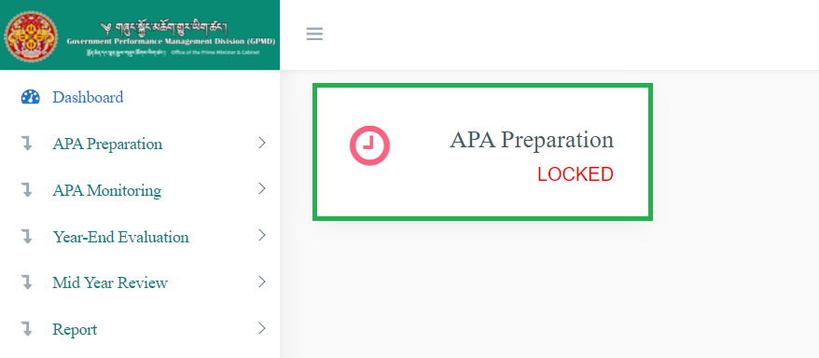
User will not get option to create new Annual Performance Agreement.
User can only view the APA already created, if any.

When Login within the APA Schedule then user is notified as follows and can starting creating APA or continue with updating the draft APA.
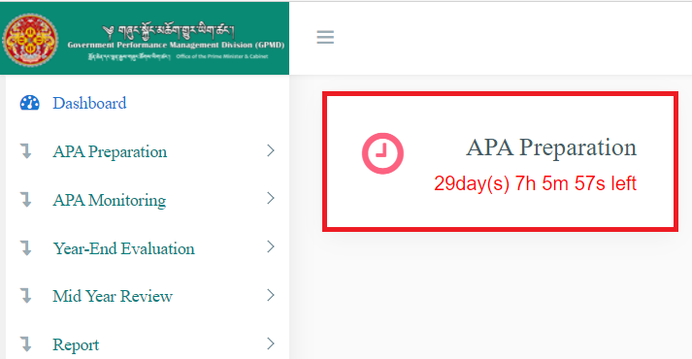
User can start creating new APA and also update the draft already saved, if any.
System provides remaining time to complete preparation of APA.
To create new APA, user is required to login and navigate to APA Preparation New APA. Following page is provided.

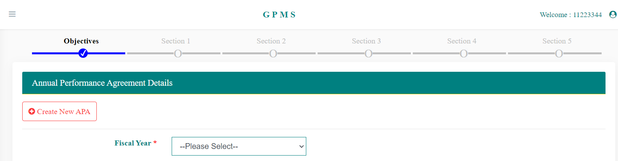
User can select the Fiscal Year to see of Draft APA exists. If Draft APA is not there then following message is provided.
To start creating new APA, user is required to click on the Create New APA button.
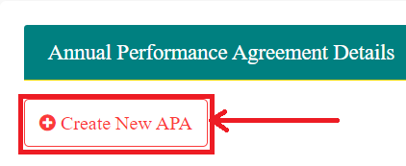
User is provided with option select Financial Year for which APA is to be created.
User selects the Fiscal Year and then click Create to create new APA. To abort creating new APA user can click Cancel.

User can continue recording other details after creating. User can continue to update APA details in future by selecting Fiscal Year. Only one APA document can be created in one Fiscal Year.
User is required to click Continue to access the information already recorded and continue recording it. Status of different sections already updated is provided on the top of the page as follows:

Section 1
Form is provided as follows for Objectives:
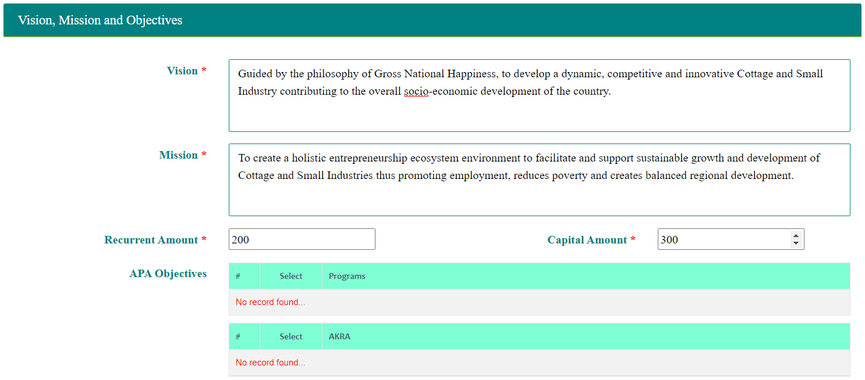
- Vision is the agency vision and mission is the agency mission.
- Recurrent Amount – Recurrent Budget Amount allocated for the fiscal year
- Capital Amount – Capital Amount is the capital budget allocation for the fiscal year
- APA Objectives – Annual objectives of the agency for the selected fiscal year. Objectives can be records as follows:
    - Select from the Program list included in the Five Year Plan
    - Select from Agency Key Result Areas in the Five Year Plan
    - Record New Objectives based on the agency priorities and conditions.
Once required information is recorded, user can click Next button to continue to next section or click Back access previous section.
User can remove added objectives if the objectives are not appropriate and add new objectives.
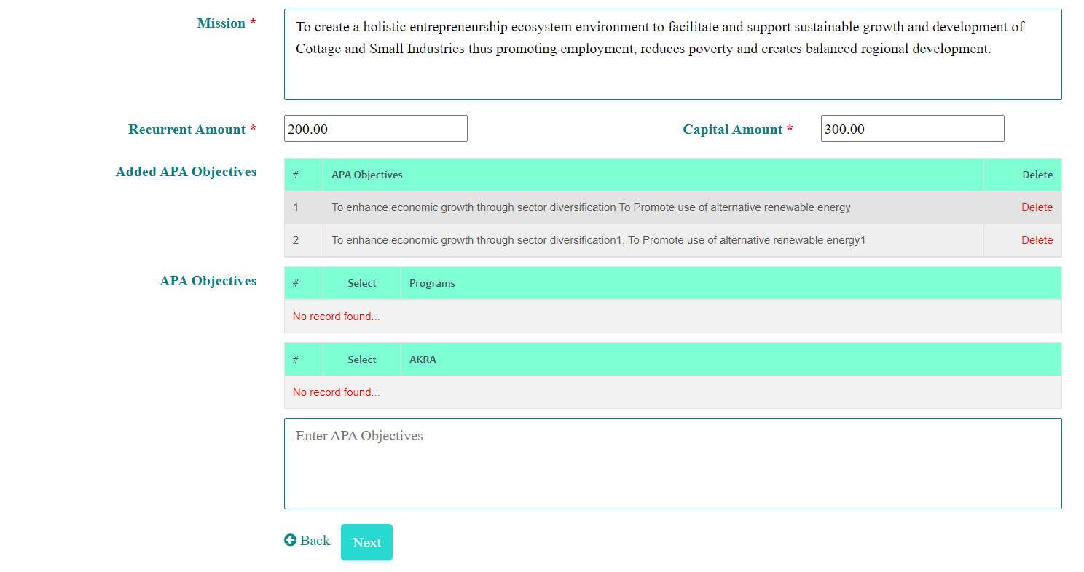
Click the Delete link against the objective that are listed under Added APA Objectives. Confirmation message is provided. OK to continue removing the objective or Cancel to abort delete action.

Section 2
When user click Next button, page to manage indicators for different objectives is provided.
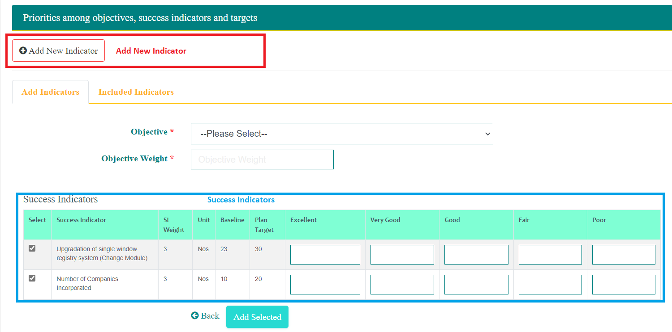
This section allows recording of new Indicators using Add New Indicator button.
This section also provides list of success indicators that are already recorded and the indicators that are included in the Five Plan. Agency can select from the list of indicators and record performance measurement data. After recording the required information will have to click Add Selected button to added the selected indicators to measure the performance of selected Objective. User should select Objective and also record weight for the objective.
Once successfully added, the indicators are listed under Included Indicators tab.
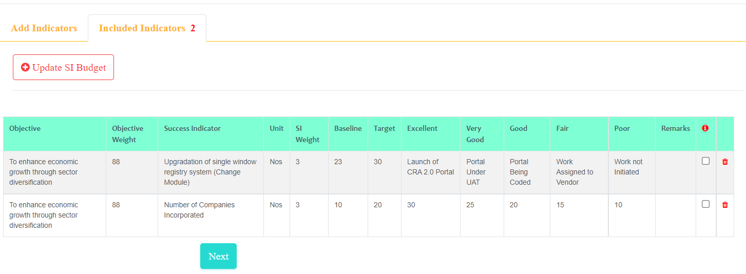
Adding of indicators should be continued for all the objectives. From the Included List of Indicators, user can remove the Indicator if felt not appropriate. To remove the indicator user can click . Confirmation message is provided. Click OK to remove the indicator or click Cancel on the confirmation box to abort removing the indicator.

Update SI Budget
User can update SI Budget for each Success Indicator. Any Success Indicator can be achieved through execution of several activities. Some activities may require budget while some may not require budget. Only capital budget requirement is expected to updated in the system.
Updating SI Budget is optional.
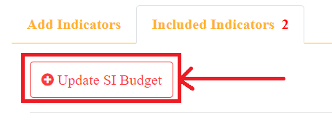
To record budget for Success Indicators, user is required to click Update SI Budget button.

User is provided with list of Success Indicators that are included in the Annual Performance Agreement.

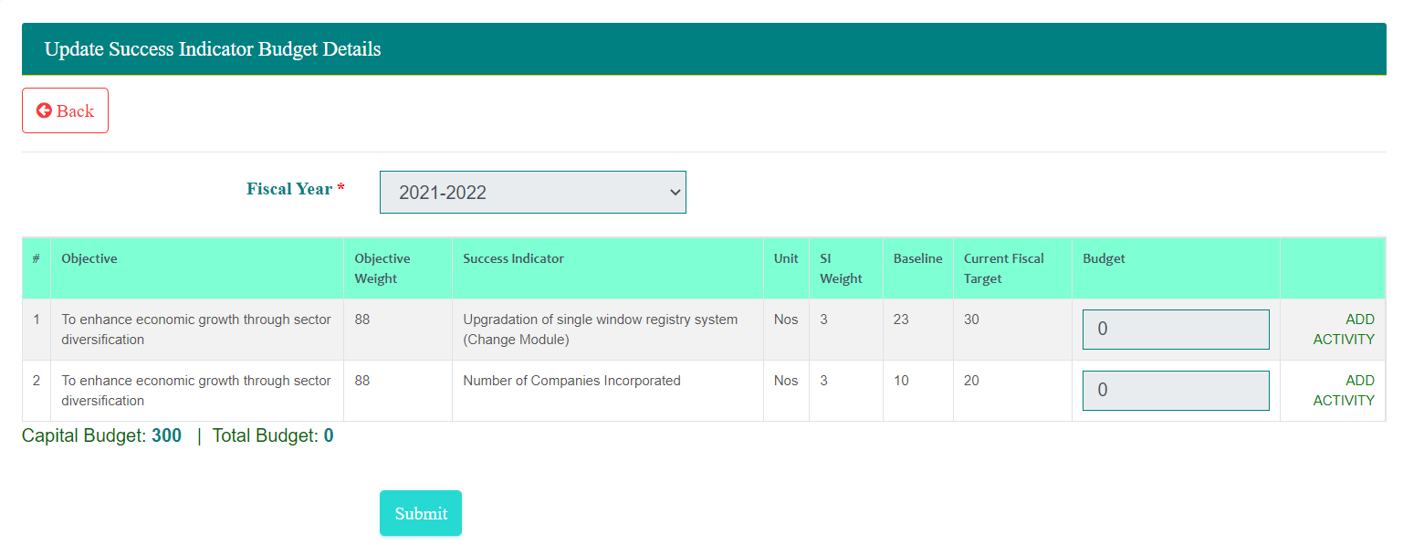
User is required to click ADD ACTIVITY link to view already recorded activities and budgets.
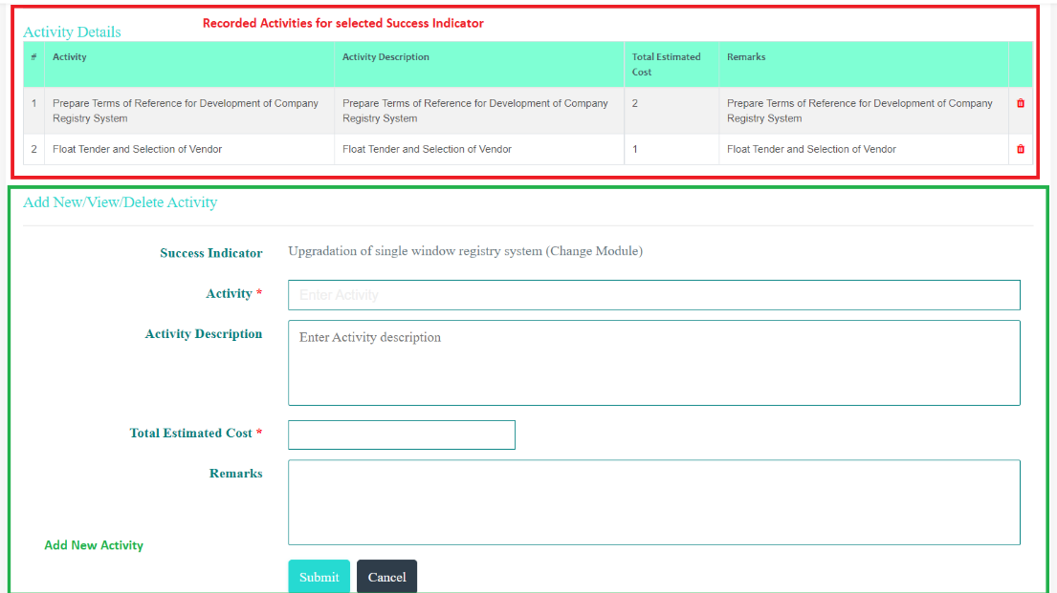
User can add new activity using Add New Activity section. If already recorded activity (ies) are not appropriate, user can delete the activity using function. A confirmation message is provided. Click OK to confirm delete task or Cancel to abort deleting activity.
As and when the activities are recorded with Total Estimated Cost, the Budget column of the SI is updated.
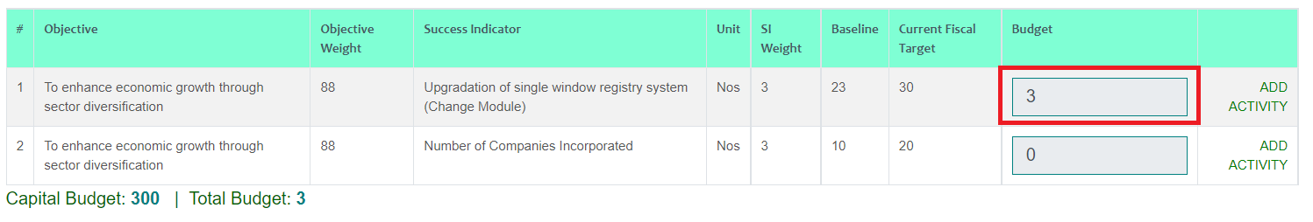
User will be warned if the activity budget exceeds capital budget. However, user can submit the details.
After recording required information, user will Submit the SI Budget details.
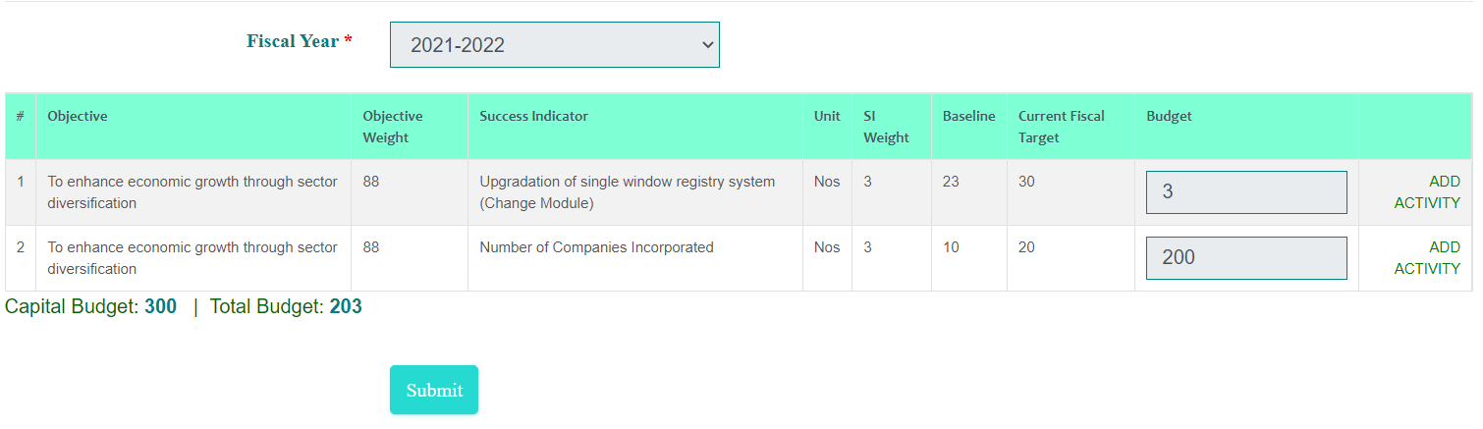
Once recording of the SI budget is complete then user can continue to section 3 of the Annual Performance Agreement. User can indicate whether the indicators will have trend values or not. User has option to select those indicators that can have trend values.
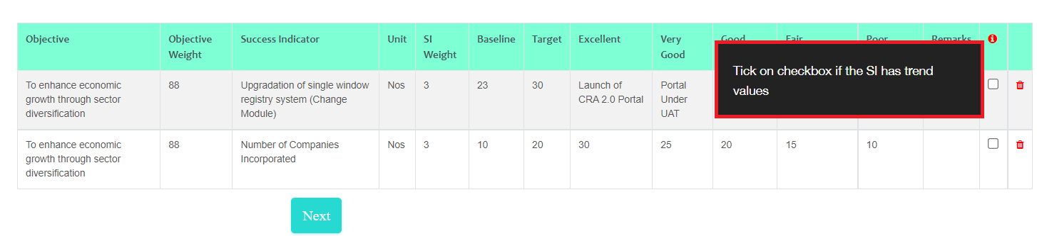
User is required to check the boxes () against the indicators that will have trend values and click Next. Section 3 (Option to record Trend Values for indicators is provided).

Section 3
Those indicators selected will be listed with trend values. The values included are from the annual targets specified while creating the Success Indicator. Yearly targets are not specified then 0 is displayed.
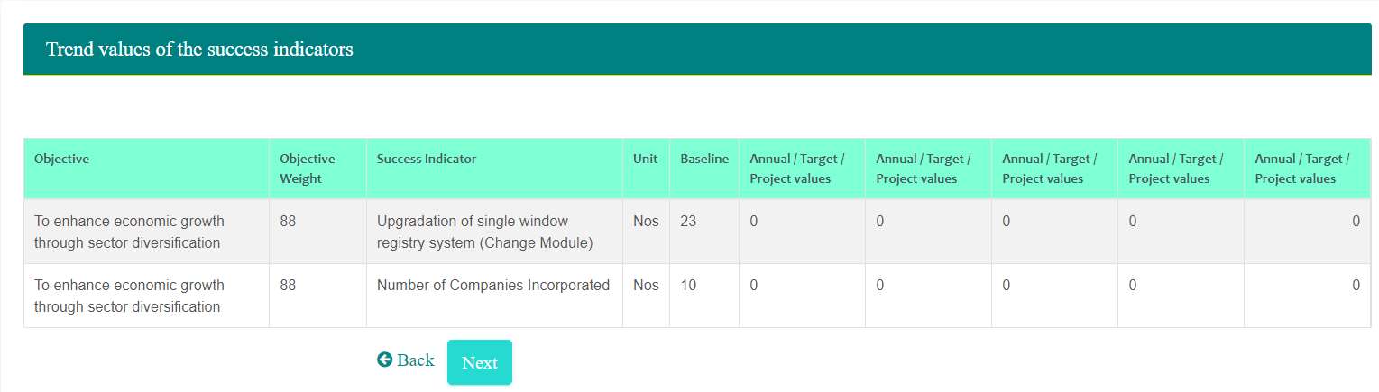
After reviewing values user is required to click Next button to move to Section 4. Section 3 is optional.
Section 4 – Definition of Indicators
User is required to update definition for all the indicators. Indicator definition page is provided as follows:
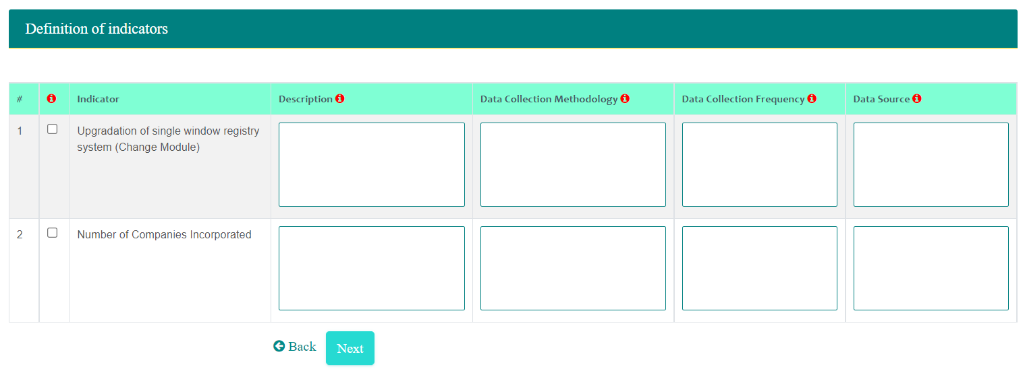
Once the indicator definitions are complete, user has the option to select the Indicators that are dependent on other Agencies.
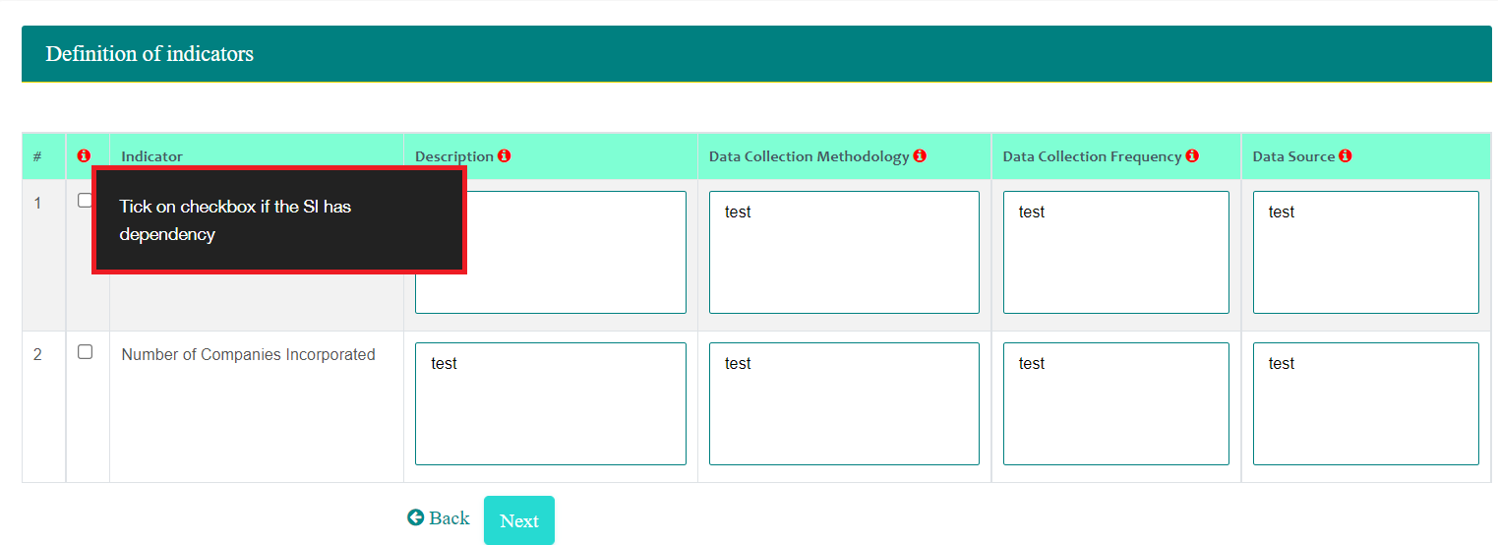
User can select the indicators that are dependent on other agencies and then click Next. If the indicators do not have any dependency then user need not select any indicator. If indicator is selected then option to record the dependency information is provided.

Section 5
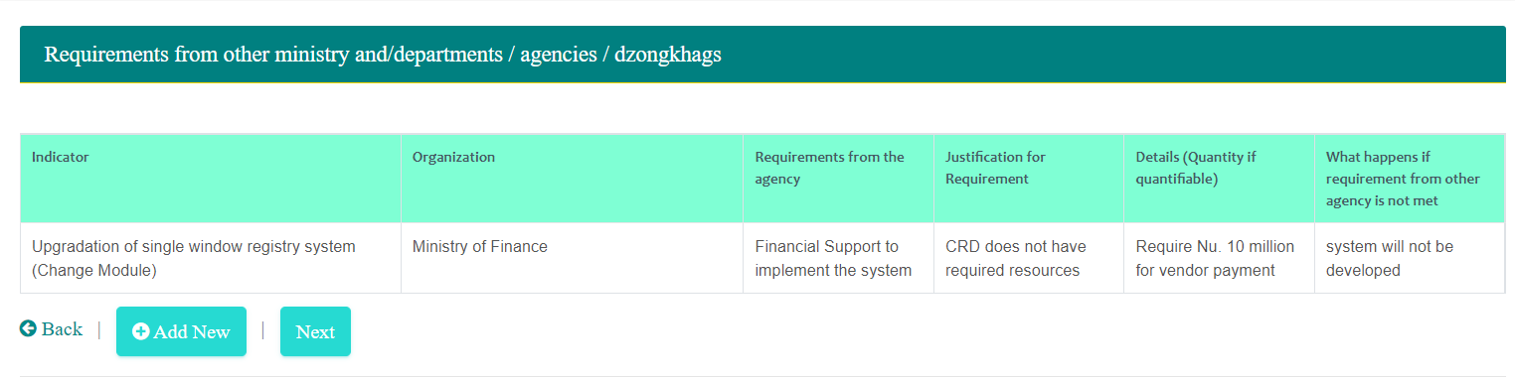
Option to add new agency is provided. To add agency click Add New button. Following page is provided.
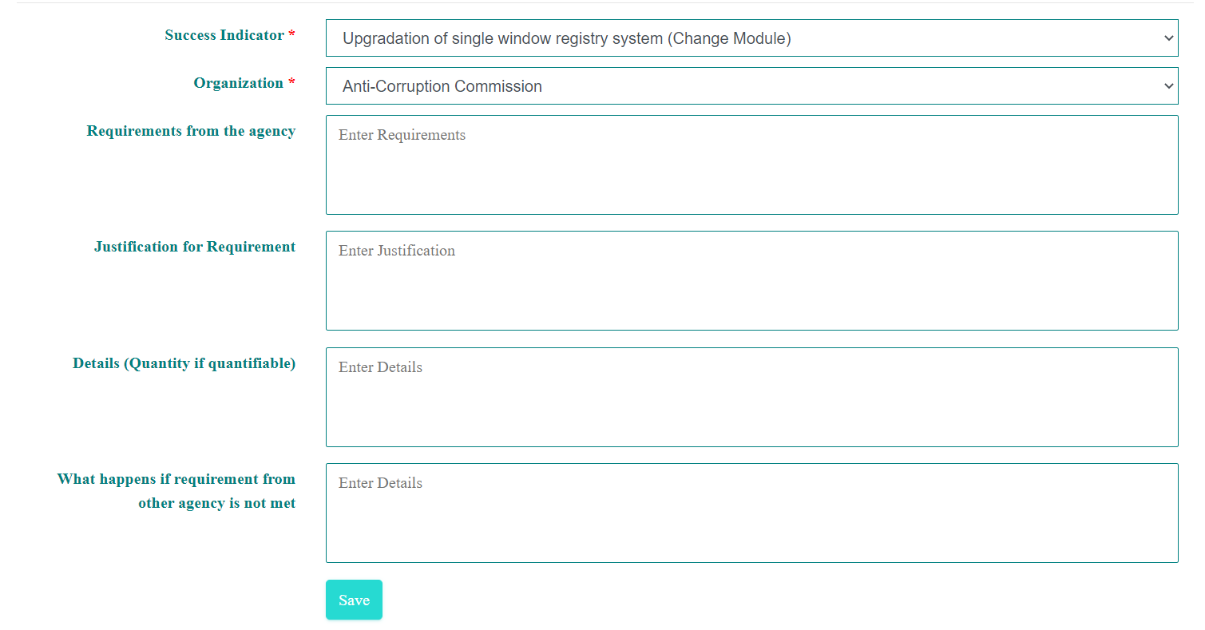

Any number of agencies can be added. After recording the information for required number of agencies, user is required to click Next button. Annual Performance Agreement Preview is generated as follows.

APA Preview
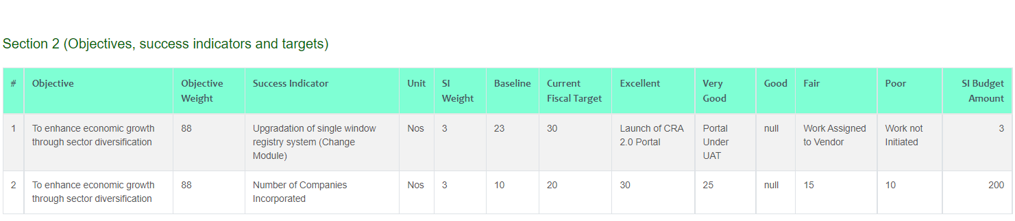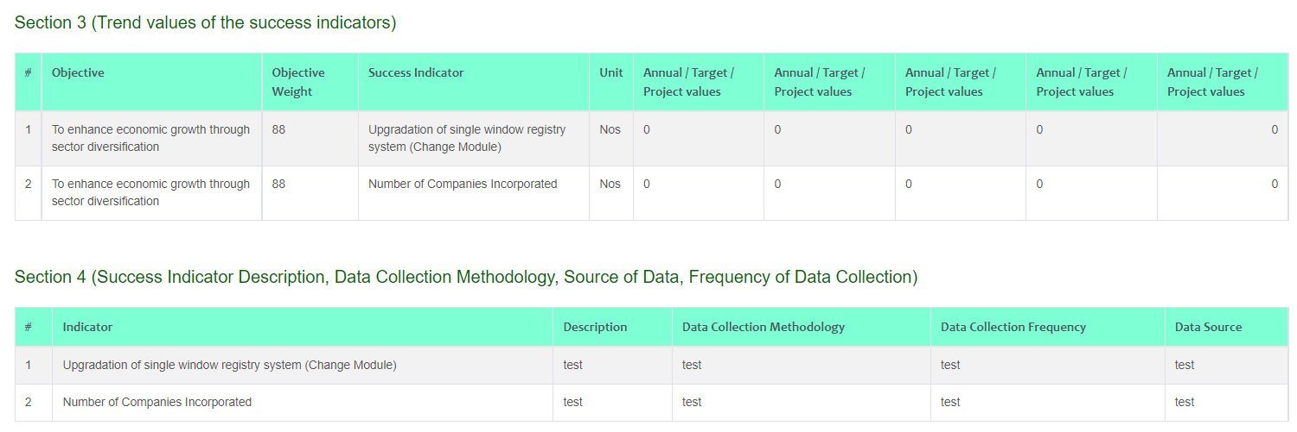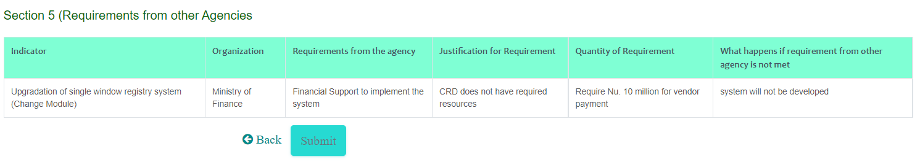
User can review the APA and then Submit if everything is OK or Back to make modifications, if required.

APA Review by IRC
Annual Performance Agreement submitted by agency is reviewed by Internal Review Committee (IRC). IRC user is usually of the parent agency of the agency that submitted the APA. For instance, APA submitted by Divisions is accessible to Department users and APA submitted by Department is accessible to Ministry. Ministry user can function as creator and IRC review update.
To update internal review authorized user does the following:
- Access the System
- Login into the using the credentials provided by admin user
- Navigate to APA Preparation -- > IRC Review Details. Following page is provided.
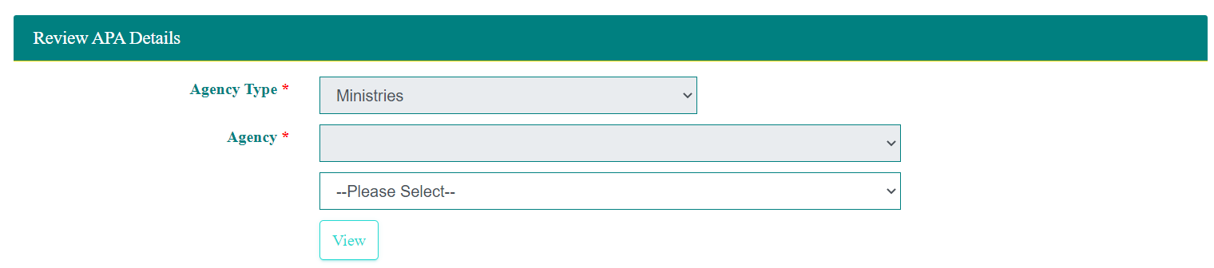
Agency is automatically selected with option to select lower agency. If user is department user then he /she can select Divisions and if the user is Ministry User then he / she can select department.
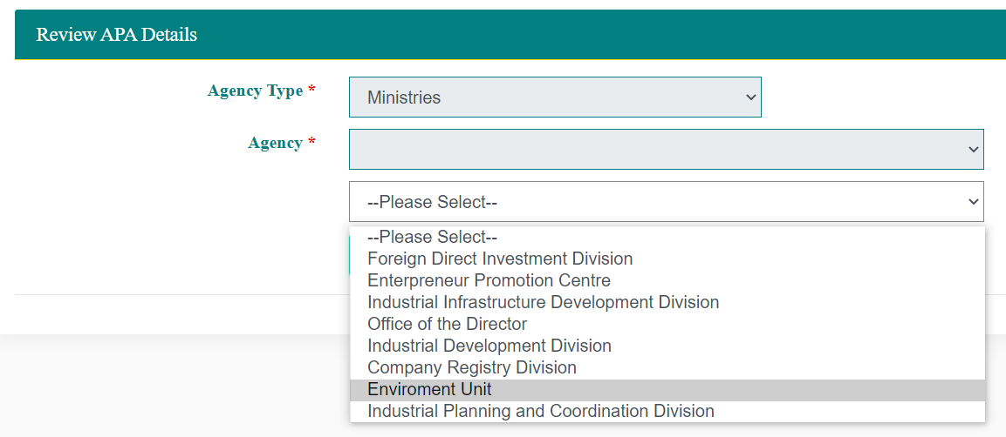
After selecting relevant values, user us required to click View. Submitted APA (if any) by the selected agency is listed.
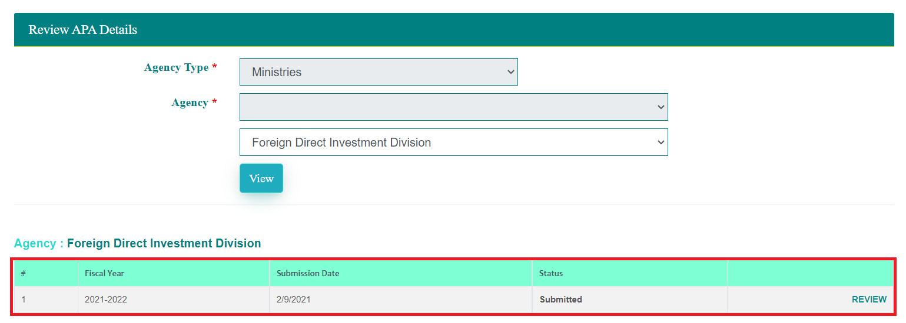
User is required to click REVIEW option to view the submitted information.
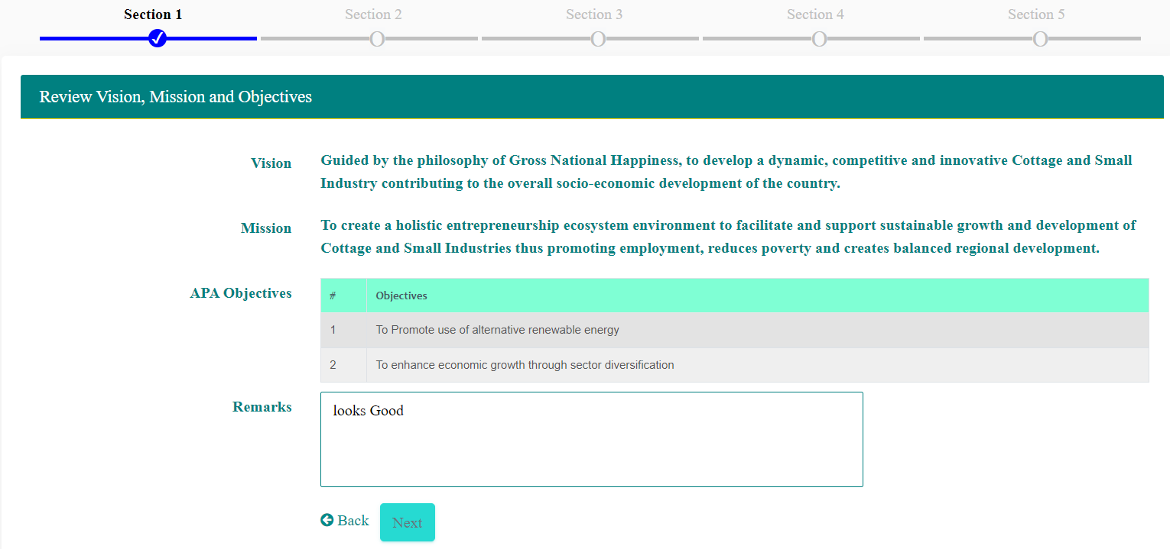
Enter the remarks if required and then click Next. Section 2 of the submitted APA is provided.
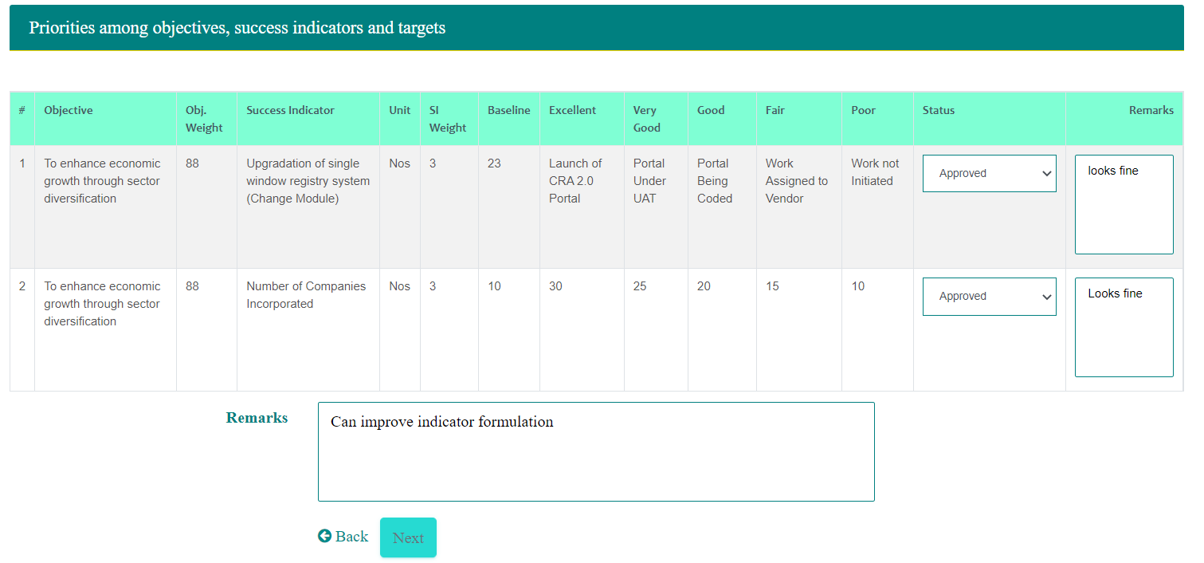
Review the indicators and provide remarks for each indicator and also over all remarks and then click Next button. Section 3 of the submitted APA is shown.
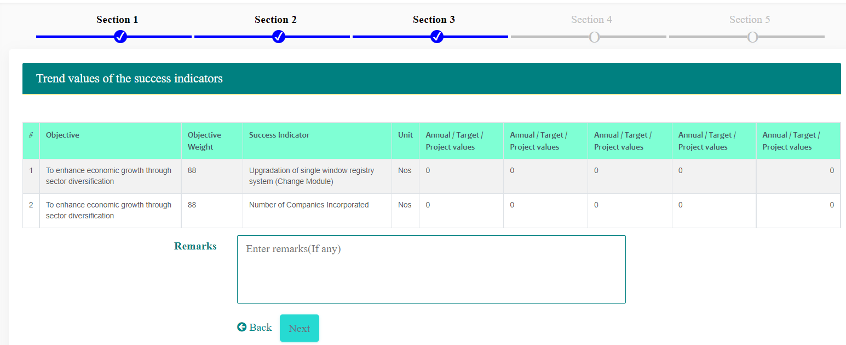
Enter any remarks (if any) on the trend values and then click Next to view section 4 of the submitted APA.
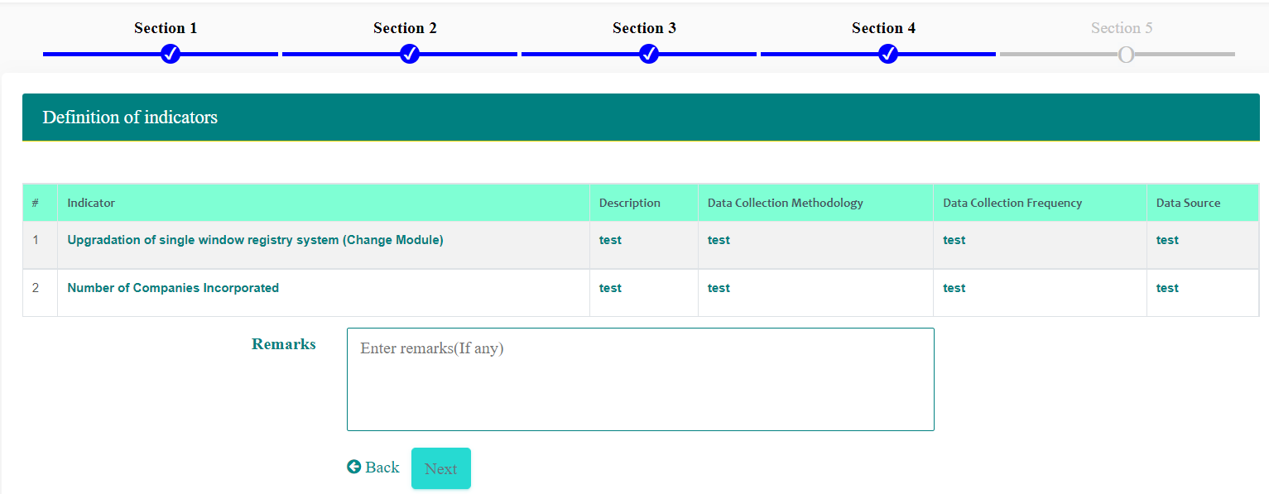
Enter any remarks (if any) on the trend values and then click Next to view section 5 of the submitted APA.
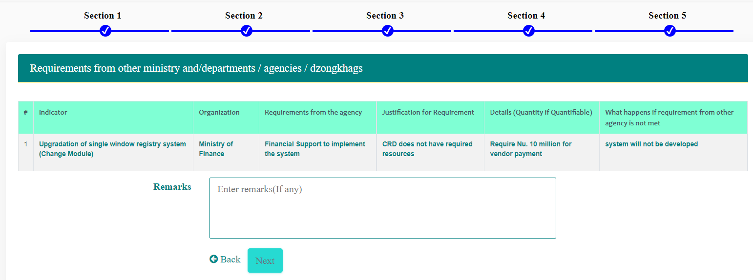
Enter any remarks (if any) on the trend values and then click Next to view preview of the submitted APA.
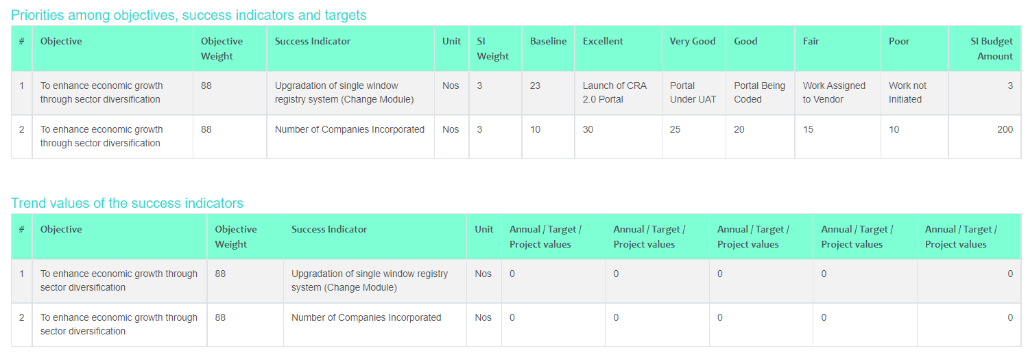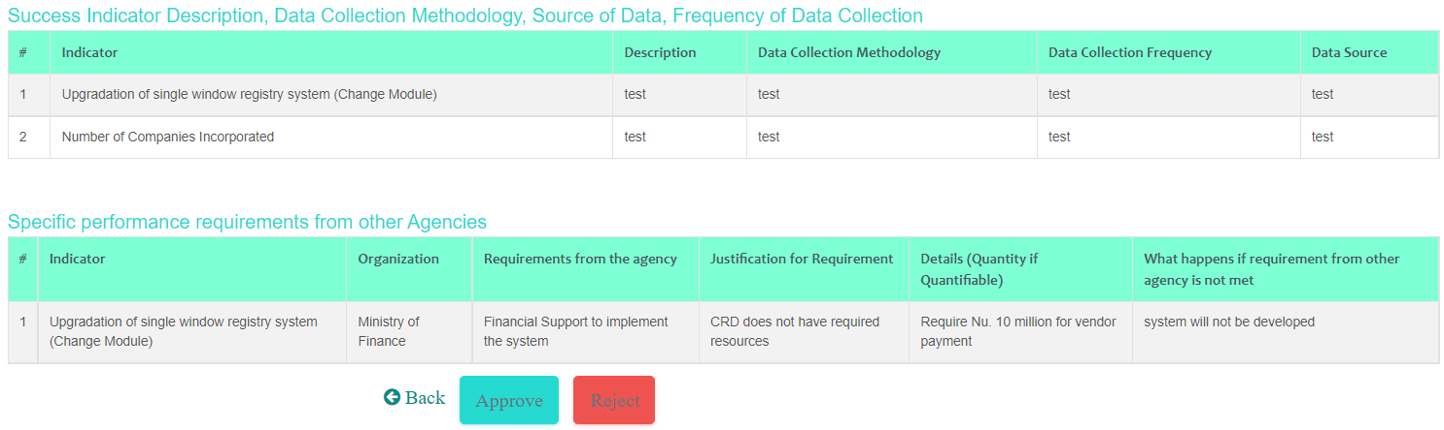
After fully reviewing the APA content user can either approve or reject. Confirmation message is provided to commit the decision. If it is rejected then user who created to APA is notified and can continue to modify and submit again.

NTC Review APA
Annual Performance Agreement reviewed and submitted by IRC user is reviewed by NTC. IRC user is usually at same level of IRC.
To update internal review authorized user does the following:
- Access the System
- Login into the using the credentials provided by admin user
- Navigate to APA Preparation -- > NTC Review APA. Following page is provided.
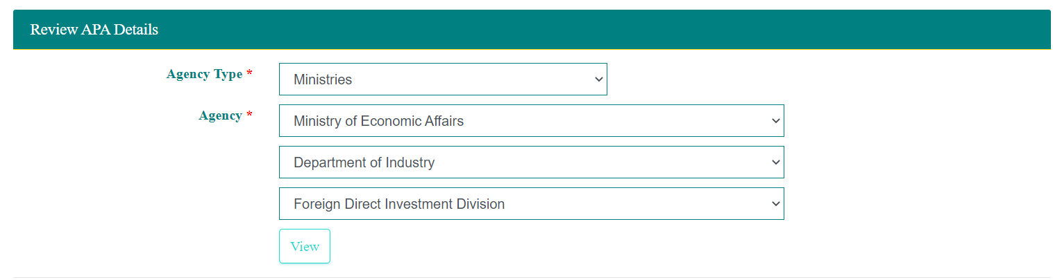
After selecting required values for agency drop down, user is required to click View button. Based on the Agency selected Departments are listed and based on the Department selected Divisions are listed. If the task is to review Ministry APA then user need not select Department. If the task is to review Department APA then Division need not be selected.
When user clicks View button, APA that is reviewed and approved (if any) by the IRC will be listed.

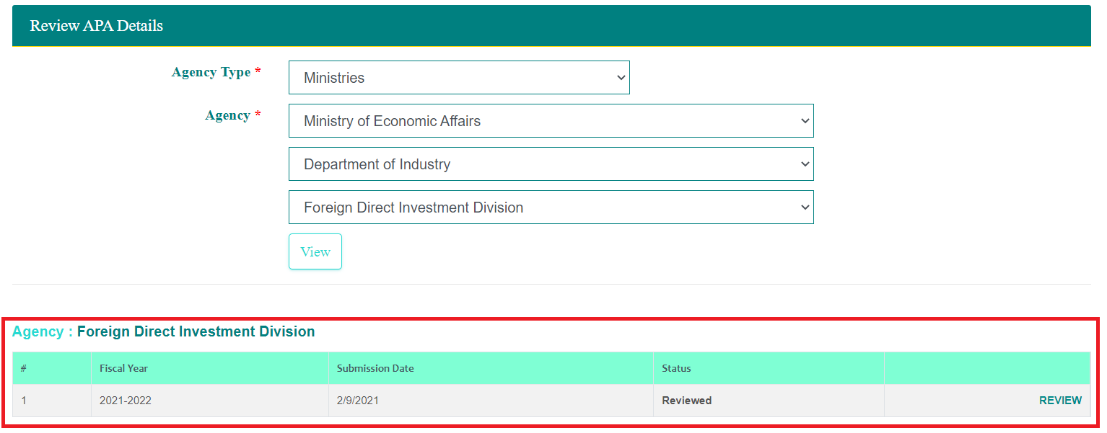
User is required to click REVIEW option to view the submitted information.
Enter the remarks if required and then click Next. Section 2 of the submitted APA is provided.
Review the indicators and provide remarks for each indicator and also over all remarks and then click Next button. Section 3 of the submitted APA is shown.
Enter any remarks (if any) on the trend values and then click Next to view section 4 of the submitted APA.
Enter any remarks (if any) on the trend values and then click Next to view section 5 of the submitted APA.
Enter any remarks (if any) on the trend values and then click Next to view preview of the submitted APA.
After fully reviewing the APA content user can either approve or reject. Confirmation message is provided to commit the decision. If it is rejected then user who created to APA is notified and can continue to modify and submit again.
Once approved by NTC, creating agency can see as reviewed APA and can only view the details.

APA Monitoring
Agencies can submit Monitoring details as Monthly report, Quarterly Report, Half yearly Report. Monitoring information submission is as follows:
- Access the System
- Login into the using the credentials provided by admin user
- Navigate to APA Monitoring -- > Monitoring. Following page is provided.
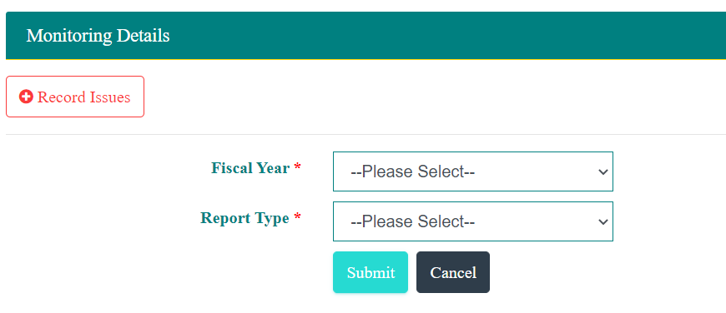
User can select Fiscal Year and then Report Type. Report Types include Monthly, Quarterly, and Half Yearly
When user selects the fiscal year, indicators included in the selected fiscal year APA are listed.
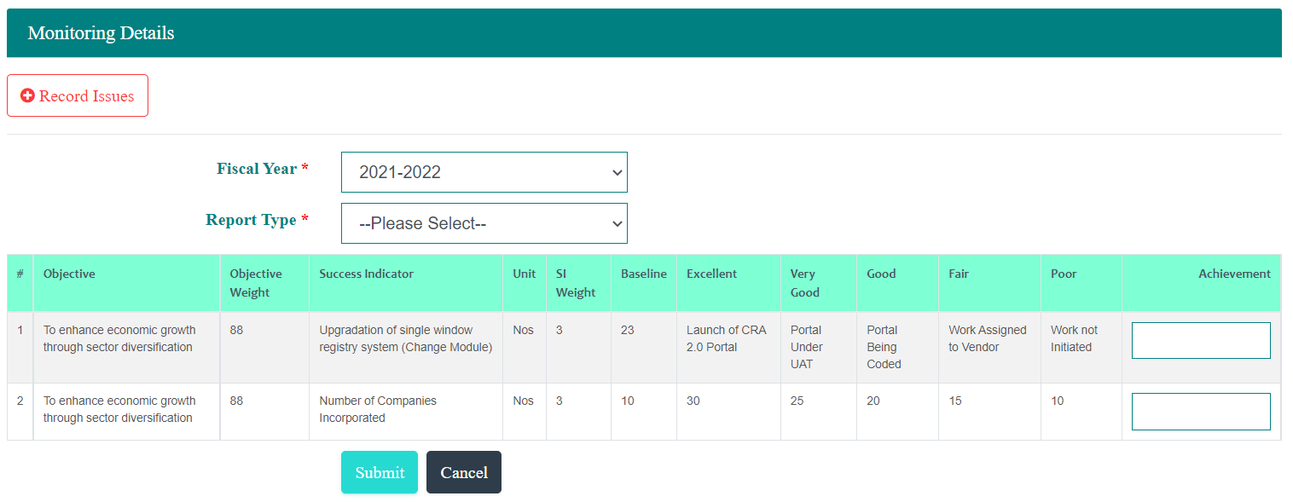
Based on the Report Type selection, following options are provided.
- Monthly Report will require the user to select the month.
- Quarterly Report will require the user to select the Quarter
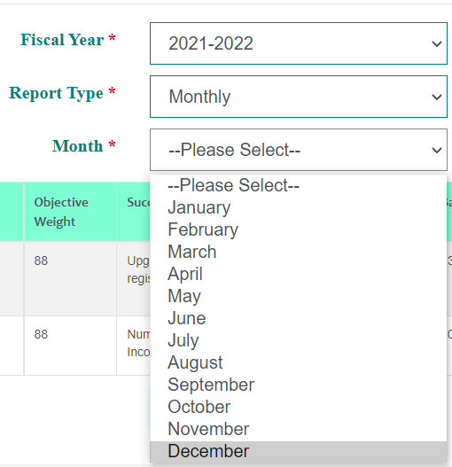
- Half Yearly Report will require the user to select the half.
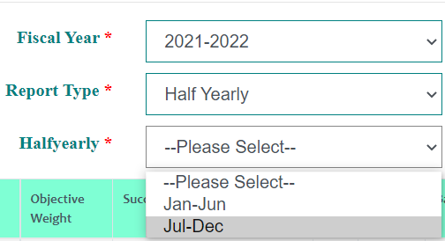
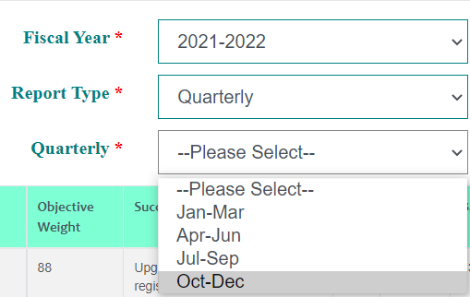

User can record the achievements for each of the indicators and Submit.

Record Issues – Departments and Divisions
Agency user can submit issues or indicate that there are no issues with the APA performance. To report issues user is required to click Report Issue button.
User is required to indicate if there are issues and user can respond as Yes or No.
If the response is not then user can click Submit button to submit no issues situation.
If the response of Yes then list of indicators is provided to allow selection impacted indicators and record issue details upon selection of fiscal year.
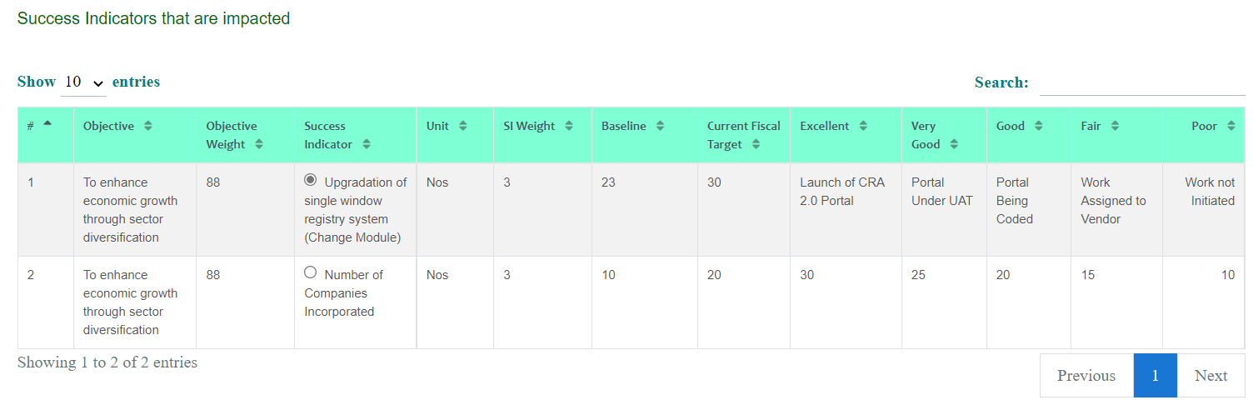After selecting the indicator, user continues to record the issue details.
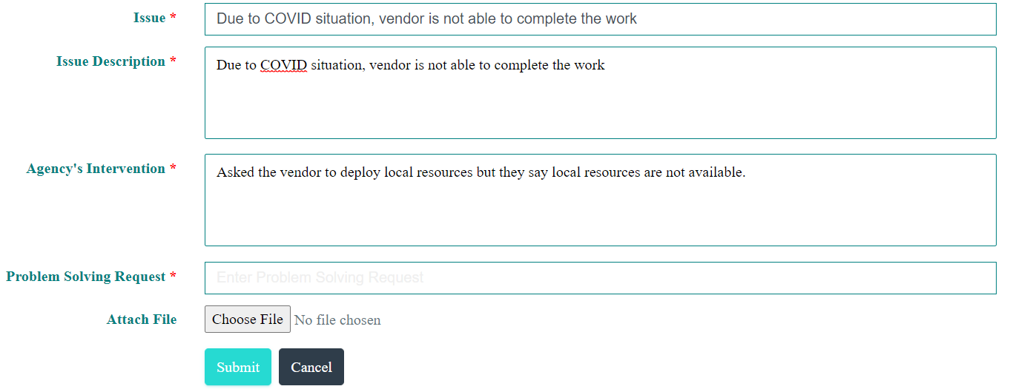
Option to attach file is provided.
Issues reported by Divisions is accessible to Department user and issues Reported by Departments is accessible to Main Parent Agency. Issues Reported by the main parent agency is accessible to GPMD for further actions.
Department and Main Agency user can view the issues submitted by the Divisions and Departments as follows:
- Access the System
- Login into the using the credentials provided by admin user
- Navigate to APA Monitoring -- > Issue Details. Following page is provided.

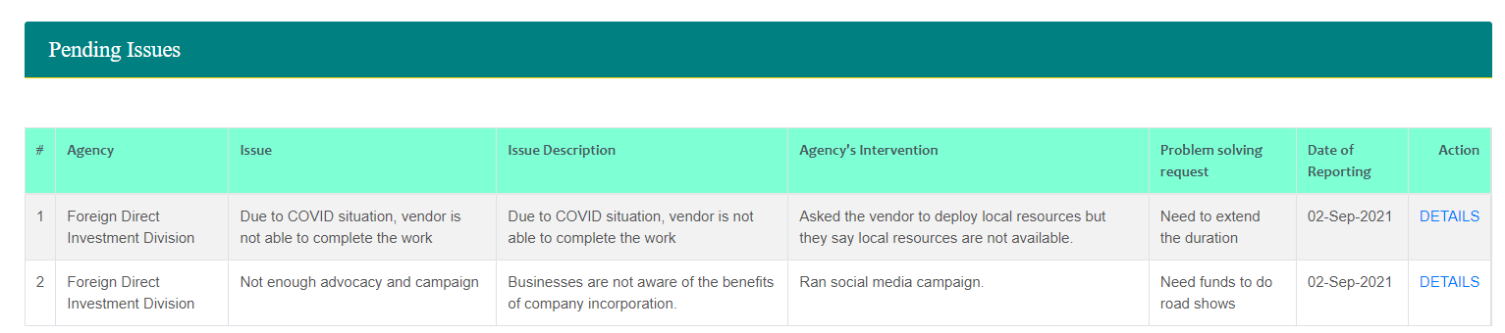
User clicks DETAILS link to view the details and update decision.
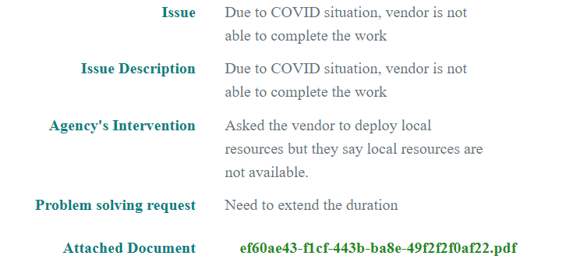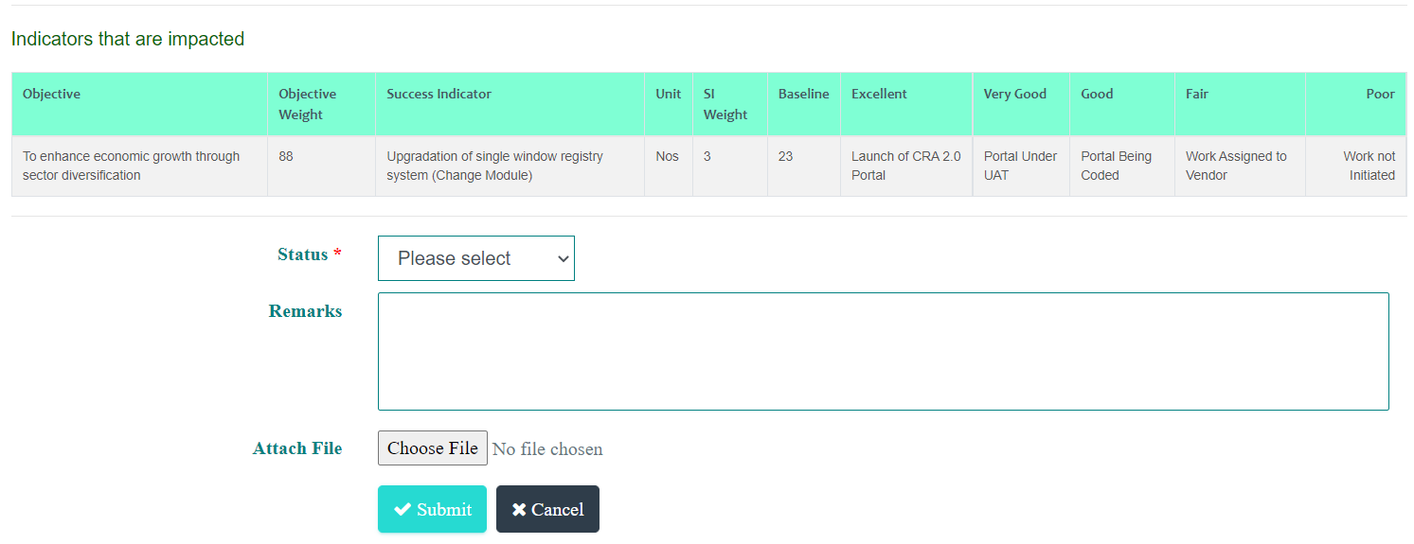

Agency Level Issues
Issues reported by main parent Agencies (e.g. Ministries, Autonomous Agencies, etc.) are reflected to GPMD for further action. A notification is generated to GPMD.
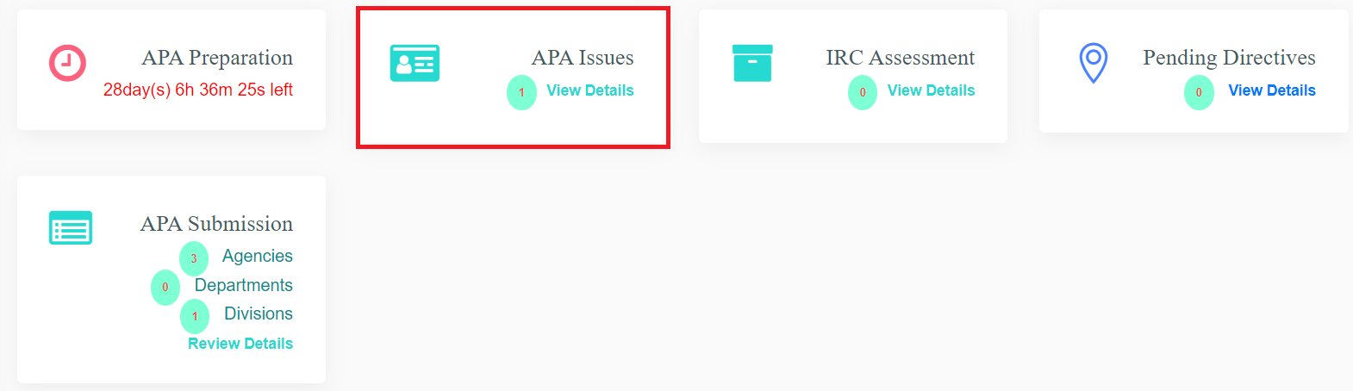
GPMD user is required click on the APA Issues box which will provide the list of issues reported by agencies.
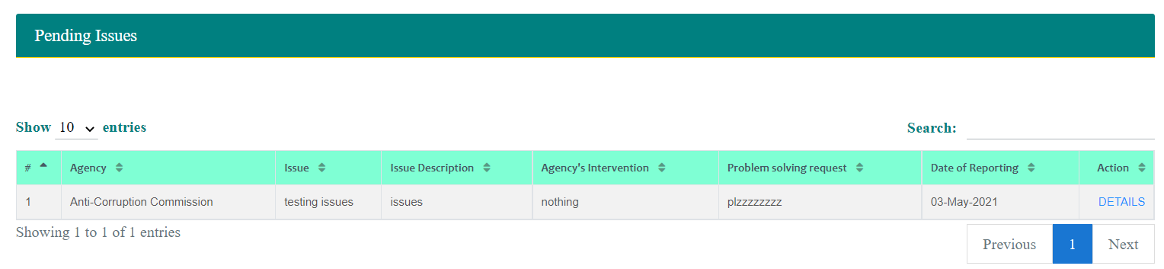
GPMD user is required to click DETAILS link to view the details of the issue reported. Issue Report will comprise of issue, action taken by the agency
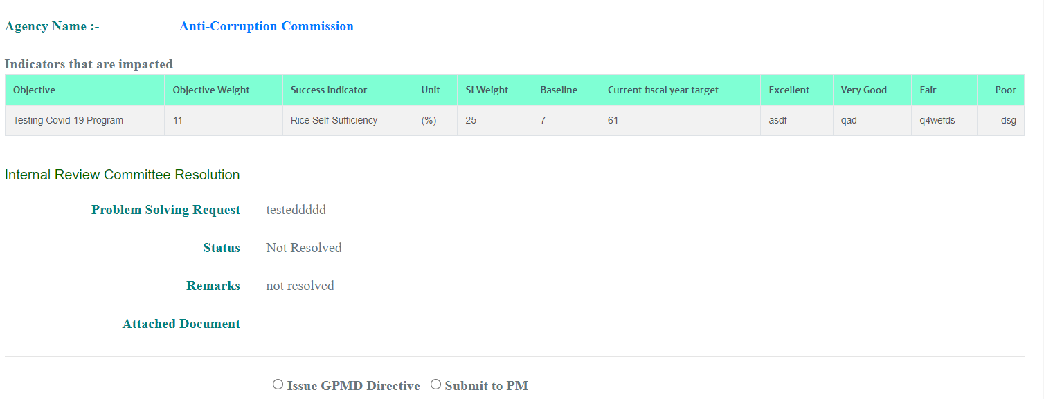
GPMD can issue directive on the issue resolution after discussion with the agency or can submit to HPM for further directives.
To issue directive from GPMD user is required to use option. Provision to capture directive details is provided.
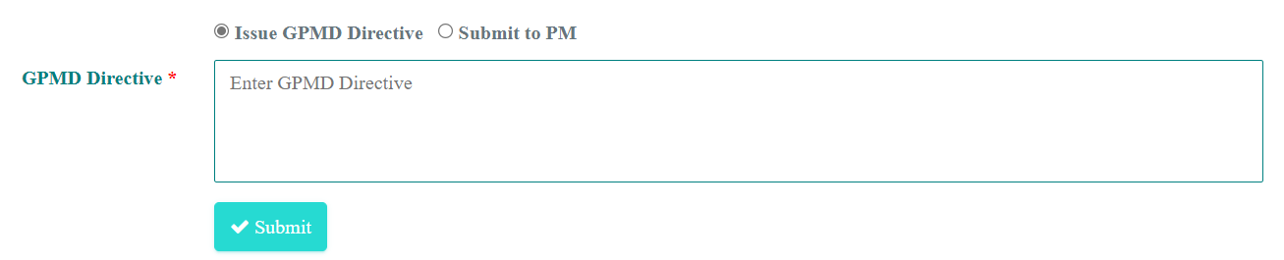
Enter the required information and then submit. Agency is notified of the directives from GPMD.
To submit issue to HPM for directive user is required to use . Option to record problem solving request is provided as below.
HPM office user will be notified on the issue submitted by GPMD.
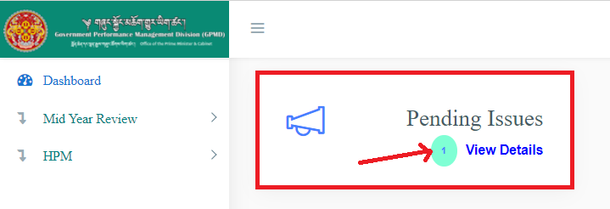
User is required to click View Details to view list of issues.
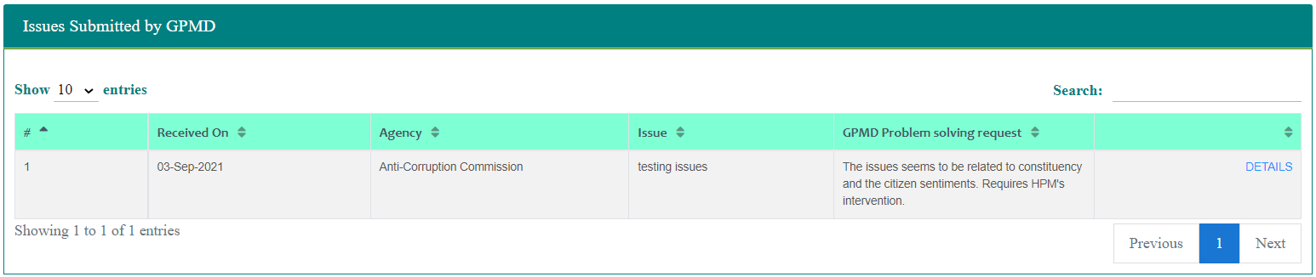
To view the details of each issue user is required to click DETAILS link.

Mid-Year Review

Mid Year Review Submission
Agencies can submit mid-year review of the annual performance agreement which can be reviewed at IRC level, NTC level and GPMD level.
Agency user can submit the Mid Year Review as follows:
- Access the System
- Login into the using the credentials provided by admin user
- Navigate to Mid-Year Review -- > Review Mid-Year Indicators. Following page is provided.
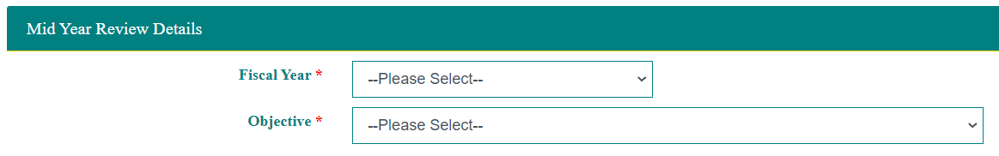
User selects the fiscal year. Based on the fiscal year selected, APA objectives are listed for selection and review. User selects the objectives to view the indicators for review.
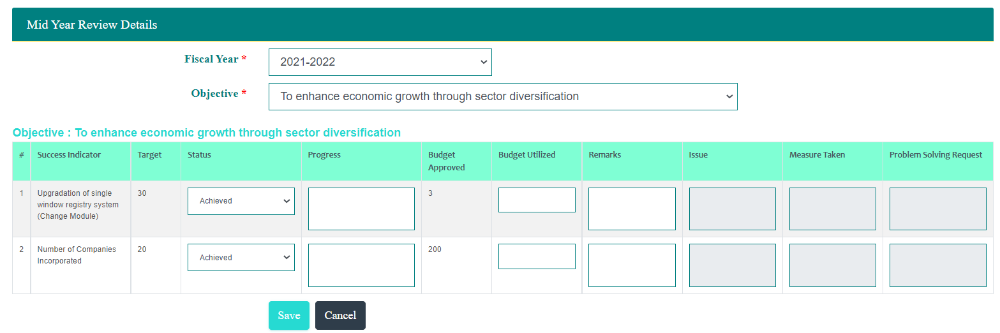
User can record each indicator as Achieved or On Track or At Risk.
- If the indicator is marked as achieved then user can provide Budget Utilized and Remarks
- If the Indicator is marked as On Track then user can provide progress, budget utilized and remarks
- If the indicator is marked as At Risk then user is required to record issue, measure taken and Problem-Solving request.
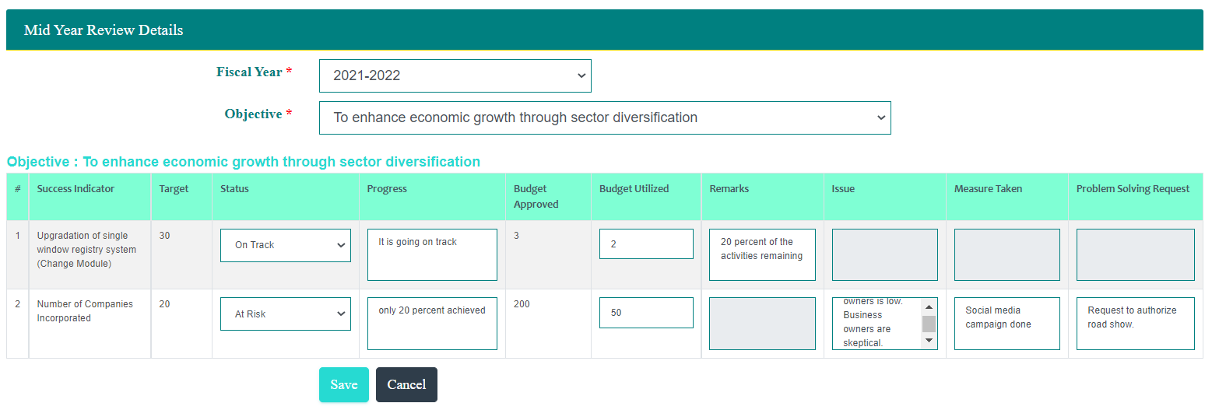
After entering required information, user clicks Submit to submit the mid-year review.

Year End Evaluation

Self Assessment
Agency user can submit the Year End Assessment as follows:
- Access the System
- Login into the using the credentials provided by admin user
- Navigate to Year End Evaluation -- > Annual Progress Update. Following page is provided.
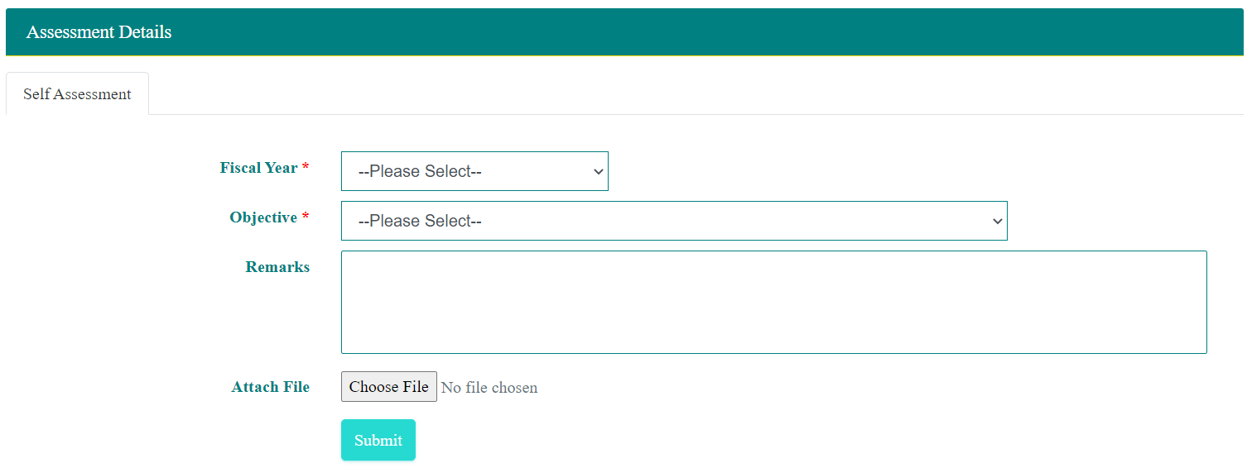
Select Fiscal Year and Objective to get the list of indicators.
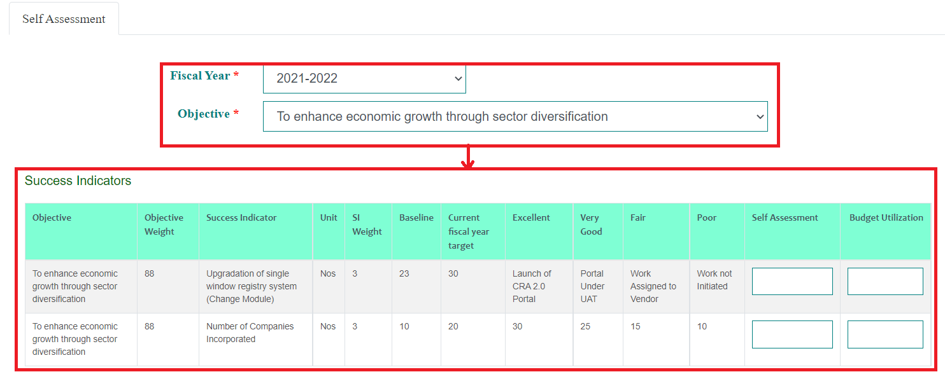
Additionally, option to record overall remarks and documents is provided.
User records required information and also attach document (if required).

IRC Assessment
Once the self-assessment is submitted by the agency, IRC can review and update IRC assessment. To update IRC assessment please follow steps as:
- Access the System
- Login into the using the credentials provided by admin user
- Navigate to Year End Evaluation -- > IRC Assessment. Following page is provided.
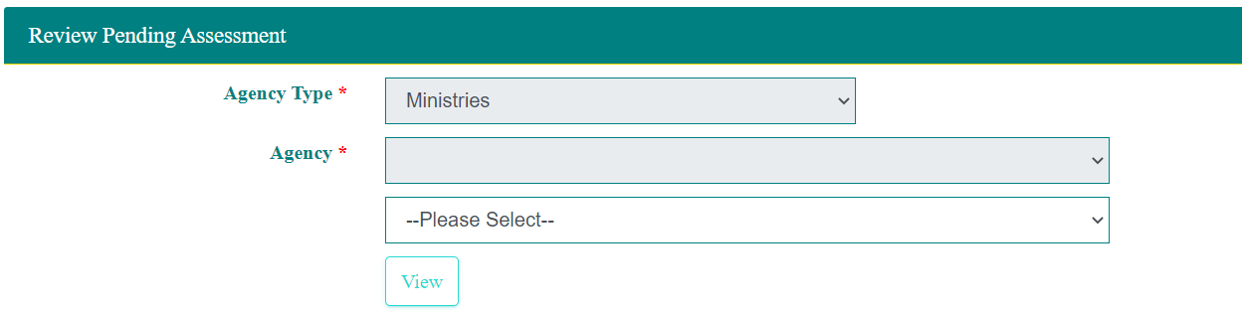
If the logged user is Department user then there is provision to select Division of which self-assessment is to be verified. If the logged in user is main parent agency user (e.g. Ministry, Autonomous Agency) then option to select the Department is available.
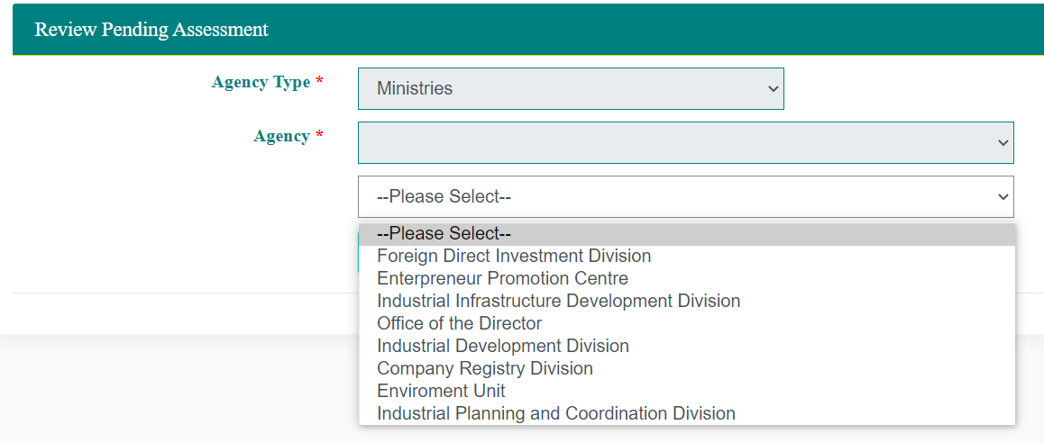
Select the relevant agency and click View, submitted self-assessment is provided.
User is required to click REVIEW link to view the self-assessment submission.
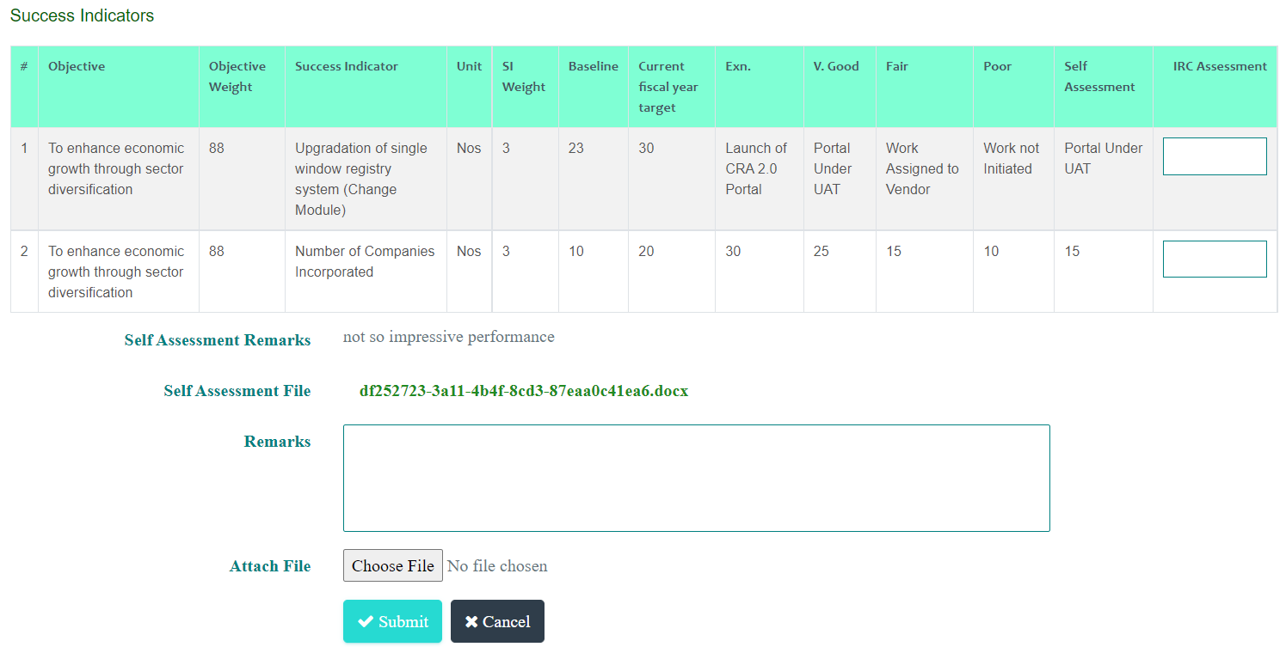
Self-assessment detail is provided with option to record IRC assessment details. If any file was attached by the agency as part of self-assessment user can open / download the file and view.
After reviewing the self-assessment, IRC assessment is updated as IRC assessment for each indicator, overall remarks and file attachment (if required).
After entering required details user clicks Submit to submit the IRC assessment.

NTC Assessment
Once the IRC assessment is submitted by the agency, NTC can review and update NTC assessment. To update NTC assessment please follow steps as:
- Access the System
- Login into the using the credentials provided by admin user
- Navigate to Year End Evaluation -- > NTC Assessment. Following page is provided.
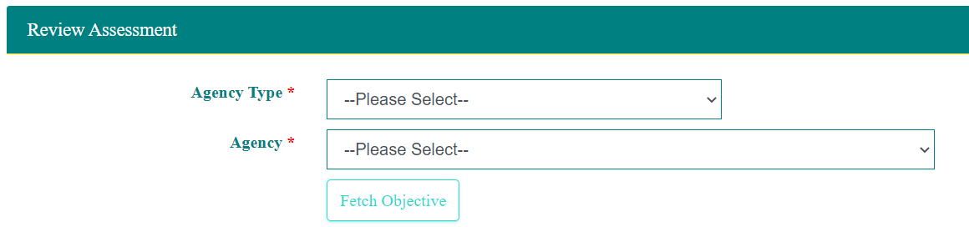
User selects the agency. Agency selection can be done up to Division level. If the APA assessment review is of main parent level then user can select Agency and click Fetch Objective. If the APA assessment review is of Department then user is required to select Agency and Department and then click Fetch Objective. If the APA assessment review is of Division then user is required to select Agency, Department and Division and then click Fetch Objective.
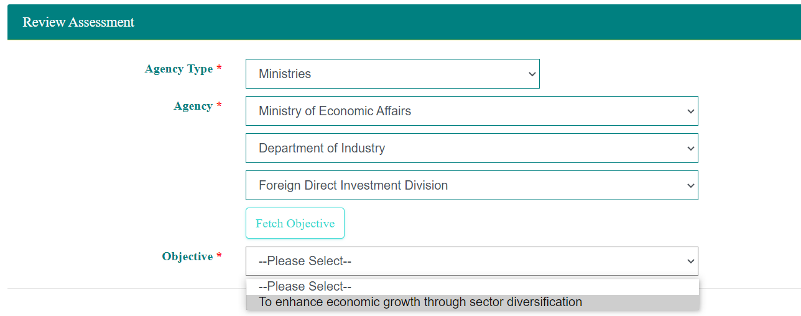
List of objectives of APA is provided for the selected agency. User selects the objective to view self-assessment and IRC assessment. Provision to record NTC assessment is provided along with self-assessment and IRC assessment.
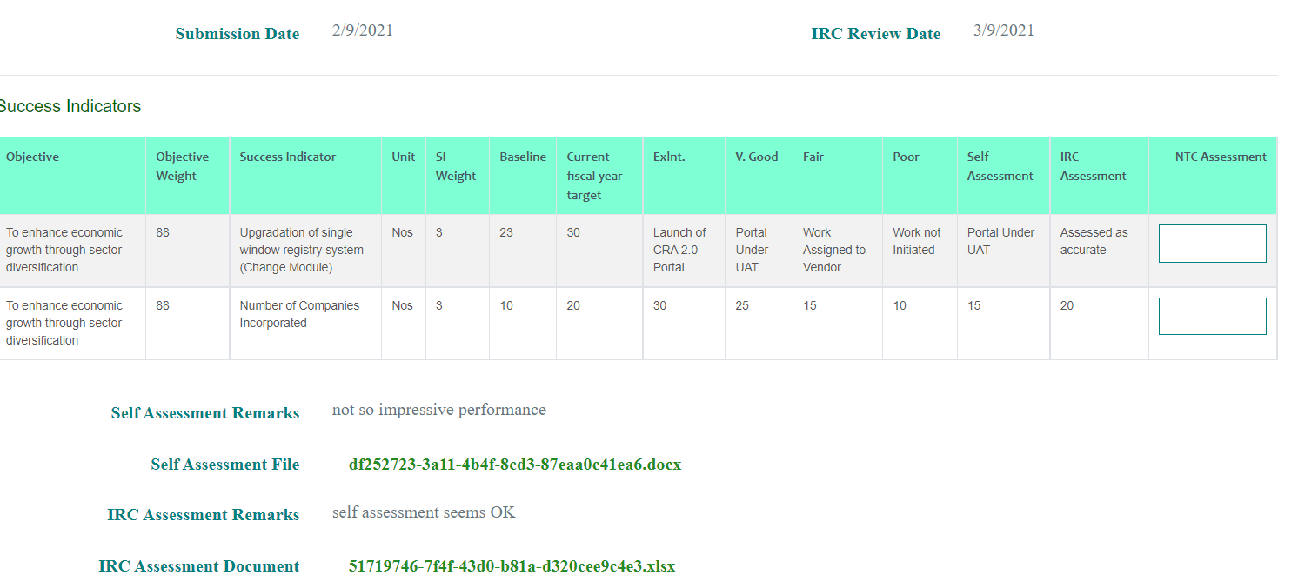
After reviewing the self-assessment and IRC assessment, NTC assessment is updated as NTC assessment for each indicator, overall remarks and file attachment (if required).
After entering required details user clicks Submit to submit the NTC assessment.

GPMD Assessment
Once the IRC assessment is submitted by the agency, NTC can review and update NTC assessment. To update NTC assessment please follow steps as:
- Access the System
- Login into the using the credentials provided by admin user
- Navigate to Year End Evaluation -- > GPMD Assessment. Following page is provided.
User selects the agency. Agency selection can be done up to Division level. If the APA assessment review is of main parent level then user can select Agency and click Fetch Objective. If the APA assessment review is of Department then user is required to select Agency and Department and then click Fetch Objective. If the APA assessment review is of Division then user is required to select Agency, Department and Division and then click Fetch Objective.
List of objectives of APA is provided for the selected agency. User selects the objective to view self-assessment IRC assessment and NTC assessment. Provision to record GPMD assessment is provided along with self-assessment IRC assessment and NTC assessment.
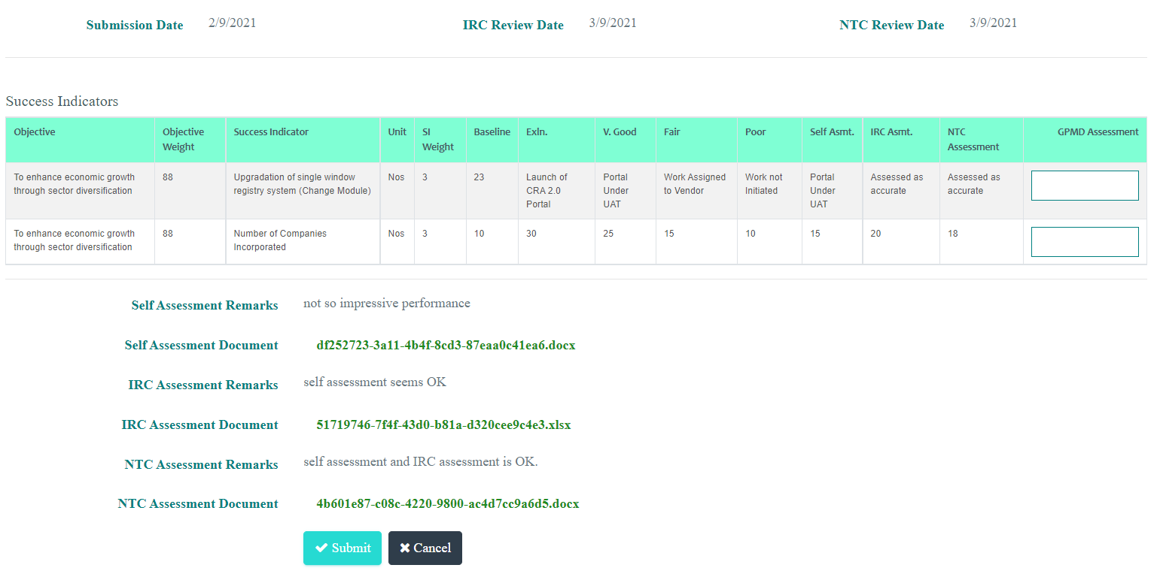
After reviewing the self-assessment, IRC assessment and NTC assessment, GPMD assessment is updated as GPMD assessment for each indicator.
After entering required details user clicks Submit to submit the GPMD assessment.

Report
Agencies can generate APA report and down load in PDF or MS Excel format.
Agency user can submit the Report as follows:
- Access the System
- Login into the using the credentials provided by admin user
- Navigate to Report. Following page is provided.
User can select Fiscal Year and then which section of APA to be generated and then click on required format. System provides option to generate All sections or section wise content in the required format.

